Functions of DBMS
- Integrity of Data-Accuracy of data
- Security- only authorized user can access
- Recovery
- Concurrency control- simultaneous access to end users.

Types of Database Systems
Database systems are categorized into four types based upon the underlying structure used to store data. These database systems in chronological order of their evolution are Hierarchical, Network, Relational and NoSql. We will now get a brief overview of these database management systems.

Hierarchical database System.
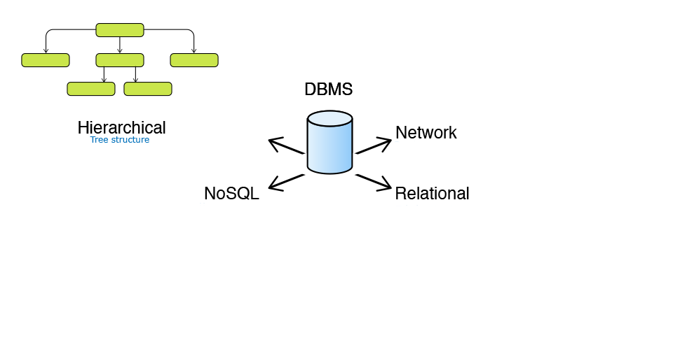
Hierarchical Databases organize data into a tree-like structure. Data is stored as records which are connected to one another through parent child relationships. Some examples of Hierarchical Databases are Information Management System (IMS), Raima Database Manager (RDM) Mobile etc.

Network Database System
Network Databases organize data into a graph structure in which object types are nodes and relationship types are arcs. Each record can have multiple parent and child records. Some examples of Network Databases are Integrated Database Management System (IDMS), Integrated Data Store (IDS) etc
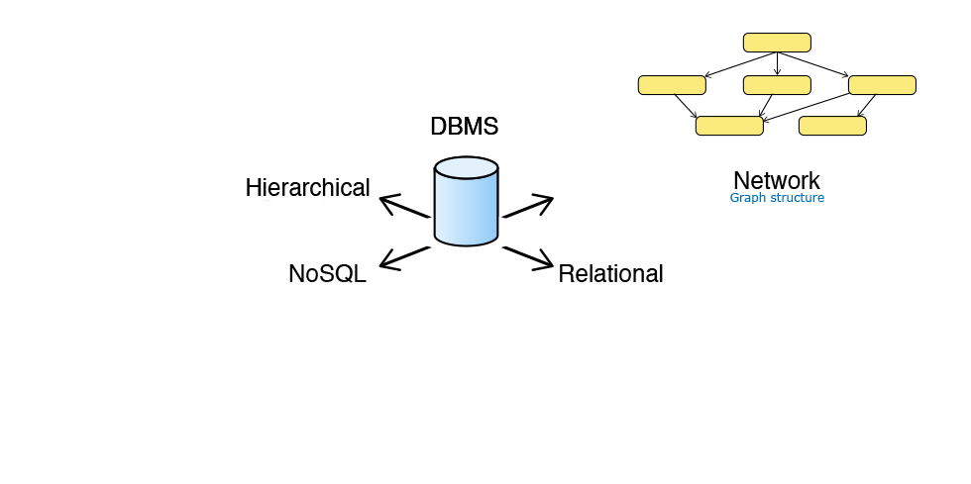

NoSQL Database System
NoSQL (Not only SQL) database uses key-value, graph or document data structures to store data. These databases aim for simplicity of design, horizontal scaling and finer control over availability. Some examples on No Sql databases are Cassandra, MongoDB, CouchDB, OrientDB, HBASE etc.

Relational Database System
Relational Databases store data in relations i.e. tables. Each relation must have a name.
An attribute is a named column of a relation. It stores a specific information about an object e.g. salary.
A tuple is a row in a relation. It represents relationship between attributes that can contain single value.
Cardinality of relation is the number of rows it contains. e.g. Cardinality of relation below is 4.
Degree of relation is the number of attributes it contains. e.g. Degree of relation below is 5.
A domain is the set of allowable values for one or more attributes.
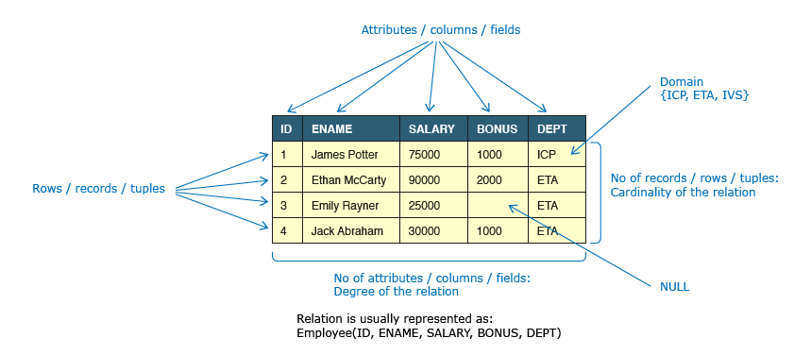

Data Integrity and Constraints
Data integrity refers to maintaining and assuring the accuracy and consistency of data over its entire life-cycle. Database Systems ensure data integrity through constraints which are used to restrict data that can be entered or modified in the database. Database Systems offer three types of integrity constraints:

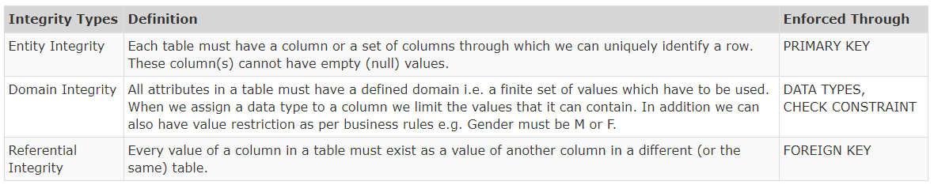

Candidate Key
A Candidate Key is a minimal set of columns/attributes that can be used to uniquely identify a single row/tuple in a relation. Candidate Keys are identified during database design, considering the basic business rules of the database. Consider the following relation with regards to a business firm:

Consider a relation R(A, B, C, D) with the following functional dependencies: A -> (B, C, D), (A, D) -> (B, C) and (C, D) -> (A, B).
Identify the candidate key(s).
Ans - {A),(C,D)

Primary Key
A Primary Key is the candidate key that is chosen to uniquely identify a row in a relation. The mandatory and desired attributes for a primary key are:
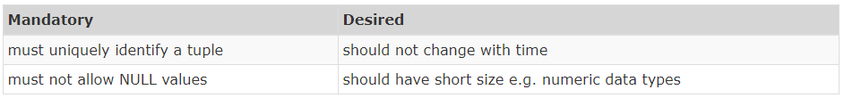
When two or more columns together identify the unique row then it's referred to as Composite Primary Key. If the combination of Name and DateOfBirth is chosen as primary key, that would be considered as composite primary key.

Foreign Key
A Foreign Key is a set of one or more columns in the child table whose values are required to match with corresponding columns in the parent table. Foreign key establishes a relationship between these two tables. Foreign key columns identified in child tables must refer to the primary key or unique key of the parent table. The child table can contain NULL values.

ER(Entity – Relationship Model)
Jack is a part of the database team and he needs to present the database design to business users. The business users are non-technical and it is hard for them to read a verbose design document. How can Jack respond? Jack needs to use an Entity Relation (ER) Model.
ER model is a graphical portrayal of entities and their relationships which helps in understanding data independent of the actual database implementation. Let us understand some of the key terms used in ER Modelling.
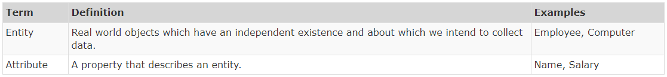

Relationships are associations of one entity with another entity through a foreign key. Each relationship has a name e.g. a Computer is allocated to an Employee.
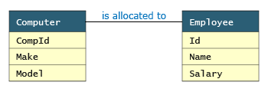
There can be more than one relationship between entities, e.g. an Employee works in a Department while the head of the department (also an employee) manages a Department.
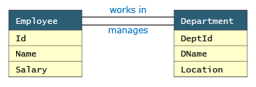
A relationship can also exist between instances of the same entity, e.g. an Employee reports to a manager (also an Employee).
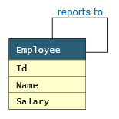

Cardinality of Relationship
Cardinality of relationship is the number of instances in one entity which is associated to the number of instances in another. For the relationship between Employee and Computer, it helps us answer questions like how many computers can be allocated to an employee, can computers be shared between employees, can employees exist without being allocated a computer etc. e.g. if 0 or 1 computer can be allocated to 0 or 1 employee then the cardinality of relationship between these two entities will be 1:1.
Cardinality of relationships are of three types: 1:1, 1:N and M:N
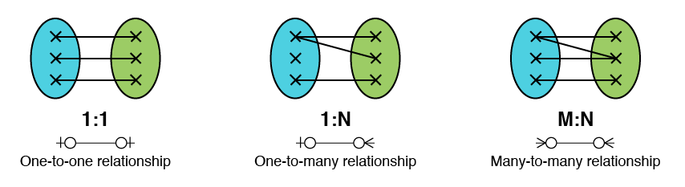

Crow Foot Notation
Crow foot notation is one of the approaches to represent the cardinality of relationship in an ER Model. The notation comprises of four symbols and one of them needs to be used for each entity in a relationship.
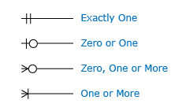
Let us say the relationship between employee and computer is such that a computer must be allocated to one and only one employee but an employee can be allocated with zero or any number of computers. Such a relationship is represented by the diagram below:
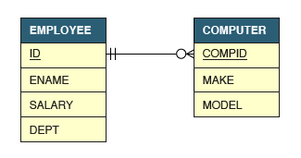

1:1 Relationship
1:1 relationship represents the relationship between a single occurrence of one entity and a single occurrence of the second entity. For e.g. consider a company where each employee can be allocated a maximum of 1 computer and computers are not shared between employees.
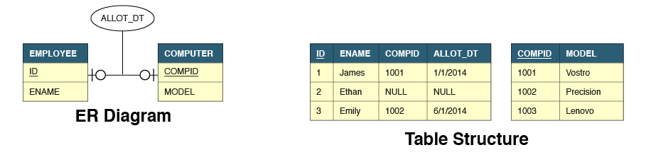
The Allot_Dt attribute is not a property of employee or computer. It belongs to the relationship and is hence represented differently in the ER Model.
We can see that the employee table has two additional attributes - CompId and Allot_Dt. CompId is a foreign key to establish the link between these two tables. Allot_Dt which is the attribute of the relationship is always stored in the table that has the foreign key.

1:N Relationship
1 : N relationship represents the relationship between the single occurrence of one entity and multiple occurrences of the second entity. For e.g. consider a company where each employee can be allocated with many computers but still, computers cannot be shared between employees.
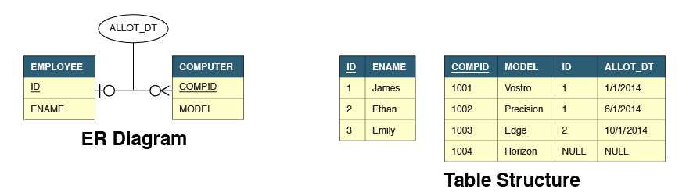
In 1 : N relationships, the foreign key and relationship attributes are always added to the many (N) side of the relationship. Hence these attributes are added to the computer table. The reverse solution will not work.

M:N Relationship
M:N relationship represents the relationship between multiple occurrences of both entities. For e.g. consider a company where each employee can be allocated with many computers and computers can be shared between employees.
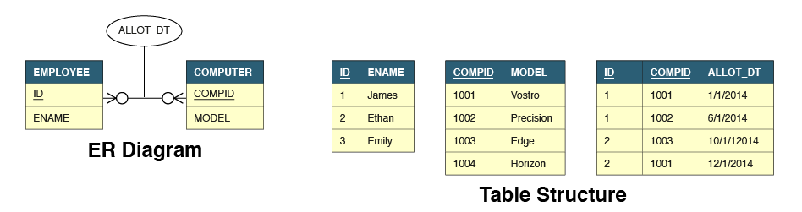
In M : N relationships, the relationship is represented by a completely new table that has a composite primary key. Such a design requires two foreign keys on the new table linking to the primary keys of each of the parent tables. The attribute of the relationship resides on this new table.
Q)In a many to one relationship, the primary key of one entity acts as foreign key on which side?
1)On the side where single (one) relationship is defined
2)On the side where many relationship is defined // answer
3)On both the sides
4) Neither of them

Data – is a collection of facts such as jack got 90 marks.
Information – processed data is information such as 90 marks means grade A
Knowledge – making sense of information such as grade A mean jack will be selected for project
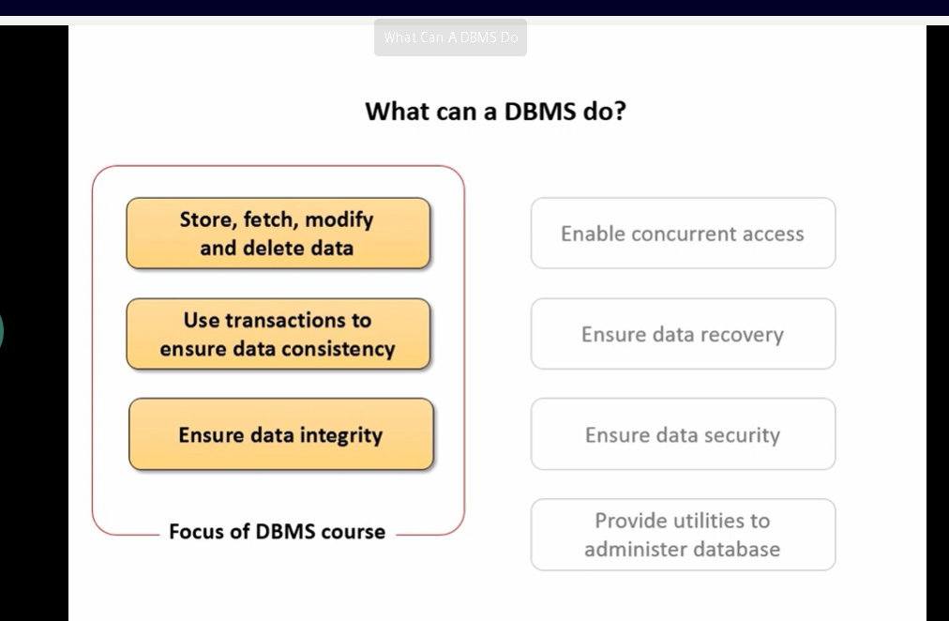

what is Self Referencing Foreign Key?
Sometimes Foreign Key of a table references back to the primary key of the same table. In that case, the Foreign Key is said to be self-referencing.
Example:
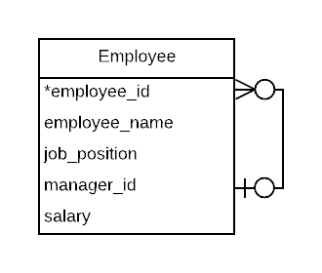

In this table, the ’employee_id’ column is the primary key and the ‘manager_id’ is the foreign key.
Each employee reports to their manager who is also an employee of the same company.

Normalization
Data redundancy occurs when the same data is multiplied across the database and can be found repeated in an unnecessary form. Consider the data stored for a retailoutletstock as per the relation given earlier.
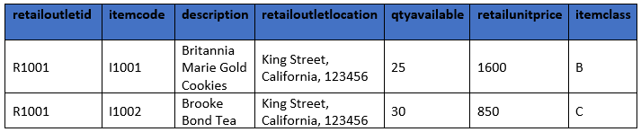
You can notice in the data stored that the retailoutletid and retailoutletlocation are repeating for every item available in the retail outlet store. This is an example of redundant information. Redundant information will lead to more disk space to store the data than actually required.

Data inconsistency results from anything that affects data integrity. This can cause the data to be correct in one place and wrong elsewhere it is stored. This can lead to unreliable and meaningless information.
Consider the following relations for the case study:
retailoutletstock (retailoutletid, itemcode, description, retailoutletlocation (street, city, zipcode), qtyavailable, retailunitprice, itemclass)
itemavailability (itemcode, description, retailoutletid, retailoutletaddress (street, city, zipcode), qtyavailable)
The retailoutletlocation in the retailoutletstock table and retailoutletaddress in itemavailability relations refer to the address of a retail outlet but present in different forms. This may lead to an inconsistent address stored for a retail outlet .To retrieve the correct address or update it , both these relations need to be considered.
The issues mentioned arise due to poorly designed/structured databases or when they are expanded without much planning to include newer elements over a period. These issues can cause huge business failures and hence must be addressed. Data redundancies can be avoided by using normalization during design of databases, inconsistency can be avoided using database constraints. As a beginner to learning databases, you will understand the importance of designing good databases and identifying databases that suffer from redundancy and inconsistency.

Normalization is the process of reorganizing data in a database to ensure that there is no redundancy of data and data dependencies are logical (all related data items are stored together).
The different stages of normalization are known as “normal forms”. To accomplish normalization, we need to understand the concept of Functional Dependencies.

FUNCTIONAL DEPENDENCY
Functional Dependencies in DBMS is a relation between two or more attributes. It can be categorized as -
- Fully Functional Dependency
- Partial Dependency
- Transitive Dependency

Suppose AB is a candidate key.
AB-> C is fully functional dependency.
B-> d is partial dependency
AB -> c and c-> f is transitive dependency.
DEPENDENCY IN A RELATION:
- An attribute of a relation can be determined by knowing one/more attributes of the same relation
- The attribute which determines the value of other attributes is known as “Determinant”
Let us consider the retailoutletstock relation.
retailoutletstock (retailoutletid, itemcode, description, retailoutletlocation(street, city, zipcode), qtyavailable, retailunitprice, itemclass)
The following are the functional dependencies in the relation:
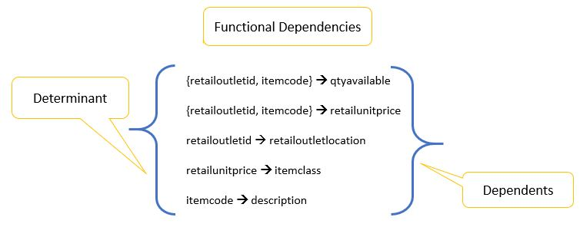
- In a relation R, A and B are attributes
- Attribute B is functionally dependent on attribute A if each value of A determines EXACTLY ONE value of B, which is represented as A -> B (A can be composite in nature)
- A is called determinant and B is called dependent

An anomaly is an unexpected side effect from trying to insert, update, or delete a row. Essentially more data must be provided to accomplish an operation than would be expected.
Consider the table retailoutletstock:
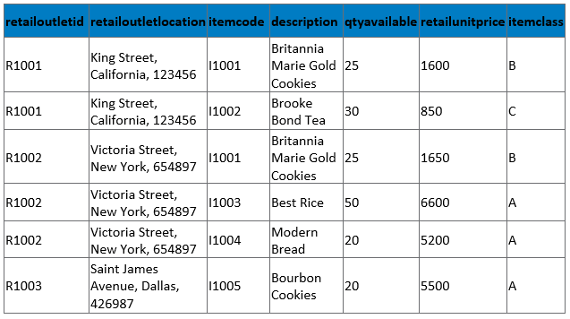
What happens if we try to insert(add) the details of a new retail outlet that currently has no items in its stock?
- NULL values would be inserted into the itemdetails columns, which is not preferable.
What happens if we try to delete the item of an itemcode I1005?
- The details of the retail outlet R1003 will also be deleted from the database.
How many rows will be updated if the retail outlet location of R1002 is changed from Victoria Street to Saint John Street?
- 3 Rows will be updated
What are the details we need to insert when new items are supplied to a retail outlet?
- Apart from all necessary details, retailoutletlocation will also be inserted which is redundant
We have seen insert, delete, update anomalies, and data redundancy in the above given example. Functional dependencies may lead to anomalies. To minimize anomalies there is a need to refine functional dependencies using Normalization.

To revisit, Database normalization is the process of structuring a relational database in accordance with a series of so-called normal forms in order to reduce data redundancy and improve data integrity. Normalization was first proposed by Edgar F. Codd.
“Normal Forms” (NF) are the different stages of normalization
- 1 NF (First Normal Form)
- 2 NF (Second Normal Form)
- 3 NF (Third Normal Form)
- BCNF (Boyce -Codd Normal Form)
- 4 NF (Fourth Normal Form)
- 5 NF (Fifth Normal Form)
- 6 NF (Sixth Normal Form)
4NF- 6NF is applicable to multivalued dependencies and complex table scenarios. Based on our course scope, we will discuss 1NF,2NF and 3NF in this module.
The retailoutletstock table has an attribute, retailoutletlocation which has the data for street, city and zipcode. Any insertion/deletion/modification performed on retailoutletlocation affects efficiency and performance.

What is 1 NF?
A relation R is said to be in 1 NF (First Normal) if and only if:
- All the attributes of R are atomic in nature
- There should not be any multi-valued attribute
How do we achieve 1 NF?
So, we will split the non-atomic attribute, retailoutletlocation into three different attributes- street, city and zipcode all of them being atomic, the resulting relation will be in First Normal Form.
The resulting retailoutletstock table in First Normal Form(1 NF) is:
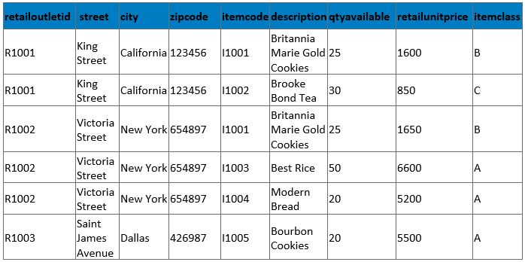
Note:- A multi-valued attribute is an attribute which can have more than one value at a time which is not the case in the above relation.
Advantage:
1 NF allows users to use the database queries effectively as it removes ambiguity by removing the non-atomic and multi-valued attributes which creates the major issues in the future while updating and extracting the data from the database.
Limitation:
As we can see in the retailoutletstock relation above, the attribute description is dependent only on itemcode (I1001->Britannia Marie Gold Cookies). Hence, we have the redundant data in the table which can be eliminated by having a separate table for item details which leads us to the next normal form.

2NF
What is 2 NF?
A relation R is said to be in 2 NF (Second Normal) form if and only if:
- R is already in 1 NF
- There is no partial dependency in R which exists between non-key attributes and key attributes
How do we achieve 2 NF?
To make a table 2 NF compliant, remove all such partial dependencies and decompose the relation.
The retailoutletstock is already in 1 NF, but we have the following partial dependencies which must be removed in order to make the relation in 2 NF.
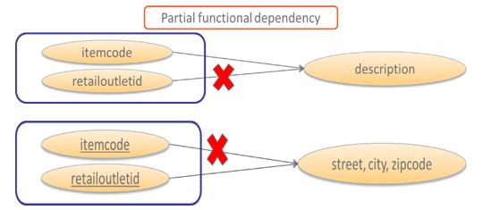
Since the description is dependent only on itemcode, we can create a separate table item with itemcode and description as its attributes, so that the partial dependencies are eliminated. Similarly, retail outlet details like retailoutletid, street, city and zipcode attributes must be in a separate table retailoutlet. Also, the attributes qtyavailable, retailunitprice, itemclass are dependent on both itemcode and retailoutletid. Hence, we will have another table retailstockdetails with those attributes.
After removing the partial dependencies, we have three tables item, retailoutlet and retailstockdetails, each of them in 2 NF.
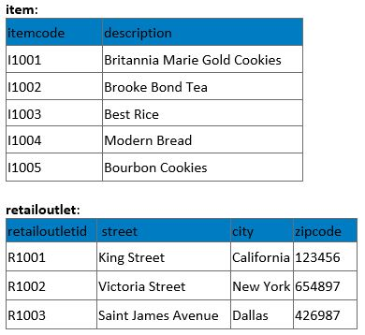
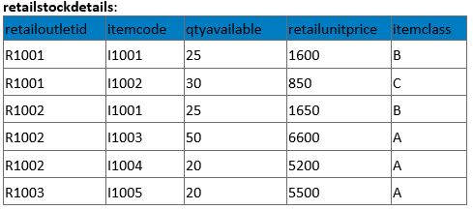
Are all the anomalies eliminated?
What will happen if we try to delete the record containing itemcode I1002 from retailstockdetails?
- The definition of itemclass C will also be lost from the database.
What if there is a change in the business rule for the itemclass, say the retailunitprice range has been increased by 1000 for every itemclass?
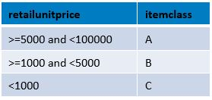
- Multiple rows have to be updated.
Insert, delete and update anomalies still exist which needs to be eliminated. This necessitates further normalization.
- The root cause of these anomalies is the transitive dependency between retailoutletid, itemcode, retailunitprice and itemclass. This needs to be eliminated.

Advantage:
2 NF attempts to reduce the amount of redundant data in a table by extracting it, placing it in a new table(s) and creating relationships between those tables.

Limitation:
Still, in the case study, we can see that itemclass attribute is completely dependent on retailunitprice and it is repeated whenever two items have the same retailunitprice. So, we still have data redundancy.
If the itemclass is changed for a range of retailunitprice, we will have to update all the records in the retailstockdetails. Which leads us to the third normal form.

3NF
What is 3 NF?
A relation R is said to be in 3 NF (Third Normal Form) if and only if:
- R is already in 2 NF
- There is no transitive dependency which exists between key attributes and non-key attributes through other non-key attributes
A transitive dependency in a database is an indirect relationship between attributes in the same table that causes a functional dependency.
X -> Z is a transitive dependency if the following three functional dependencies hold true:
- X->Y
- Y does not ->X
- Y->Z
How do we achieve 3 NF?
To make retailstockdetails 3 NF compliant, we must remove all such transitive dependencies by decomposing the relation.
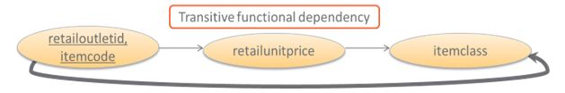
Note:- The item and retailoulet tables are not having any transitive dependency.
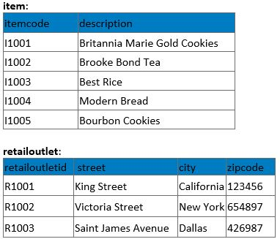
After removing the transitive dependency from retailstockdetails, it will result in the following tables.
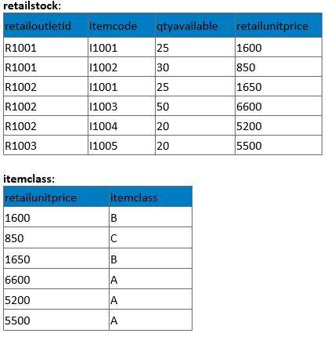
Even after converting to 3 NF, we can see that storing itemclass for every retailunitprice is not an efficient way. So, it is more appropriate to store it in the following way:
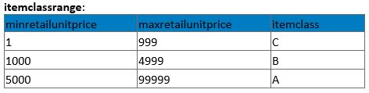

Advantage:
3 NF ensures data integrity. It also reduces the amount of data duplication.

Q) R(ABCD)
AB -> CD
D -> A is it in third normal form.
Ans ->
Candidate Key AB+ = ABCD
But there is one another candidate key
DB+ = ABCD
So prime attributes are {A,D,B}
Non prime Attributes ar {C}
Now there is not any nonprime -> nonprime so table in 3NF.

Let us summarize the learning through the diagram given below.
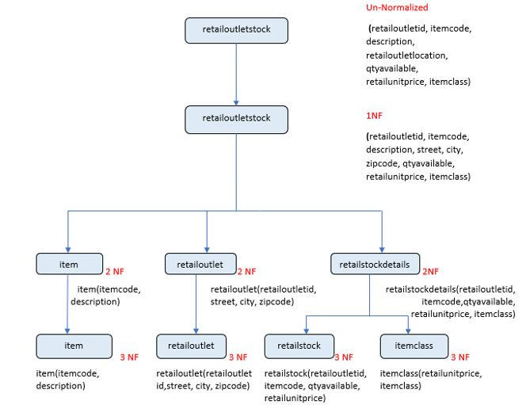

Guidelines for using normalization:
- Depending on the business requirements, the tables can be normalized up to 2nd normal form or 3rd normal form
- Tables in 3 NF are preferred in applications with extensive data modifications
- Tables in 2 NF are preferred in applications with extensive data retrieval
- Reason: retrieving data from multiple tables is a costly operation
- Converting the tables from higher normal form to lower normal form is called “Denormalization”

Database design is critical to a database management system that meets the data requirements of an enterprise system. We have explained the need for normalization, functional dependencies and normal forms in this module. The image given below summarizes the conversion of relation from an unnormalized form to third normal form:
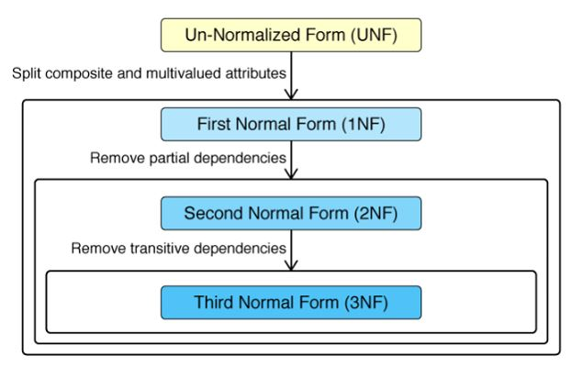

MYSQL

Change user
> system mysql -u <username> -p

Create database
> create database databasename;

Switch database
> use databasename

>show databases; // to see all databases;
> select current_user() // to see current user.
>show tables; // to see tables;

Case sensitivity in mysql
Mysql is case insensitive.
When searching for partial strings in MySQL with LIKE you will match case-insensitive by default*. even ‘=’ also case insensitive and distinct as well.
>SELECT name FROM users WHERE name LIKE 't%'
Test
test
If you want to match case-sensitive, you can cast the value as binary and then do a byte-by-byte comparision vs. a character-by-character comparision. The only thing you need to add to your query is BINARY.
SELECT name FROM users WHERE name LIKE BINARY 't%
test

Structured Query Language (SQL) is used to manage data in all relational databases like DB2, Oracle, SQL Server etc. SQL standards are maintained by ISO. While most database products comply with the ISO standard, they also offer additional proprietary features. In this course we will restrict ourselves to feature set offered by Oracle database.

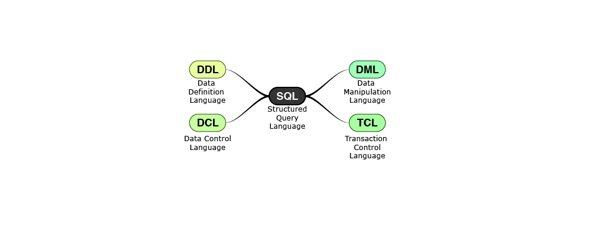

DDL
Data Definition Language is used to specify the structure i.e. schema of a relational database. DDL provides commands for creation, modification and deletion of various database objects like tables, views, stored procedures, indexes, constraints etc. The output of DDL is placed in data dictionary which contains metadata i.e. data about data.
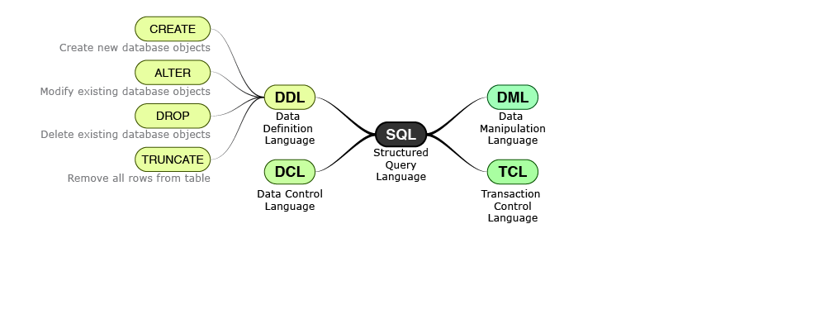

DML
Data Manipulation Language enables users to access or manipulate data in a relational database. DML provides commands for retrieval, creation, deletion and modification of information in a database. DML requires a user to specify what data is needed without specifying how to get it. The database engine is left to figure out effective means of retrieving data.
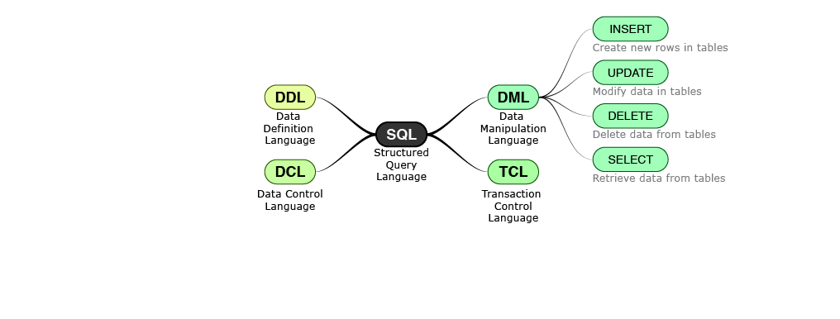

DCL
Data Control Language enables users to provide access to various database objects like views, tables, stored procedures etc. in a relational database. Typically only DBAs have access to grant and revoke privileges. Whenever a user submits a query, the database checks against the granted privileges and rejects the query if it is not authorized.
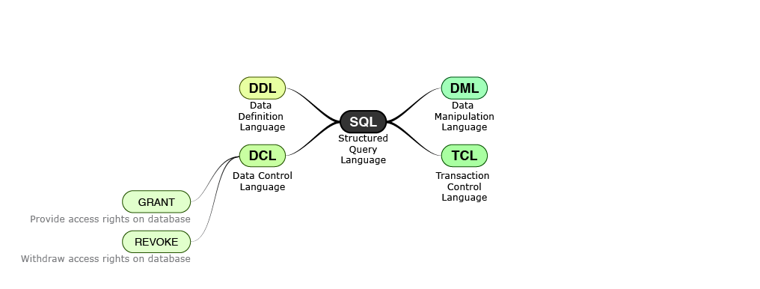

TCL
Transaction Control Language specifies commands for beginning and ending a transaction. A transaction consists of a sequence of SQL statements that are applied in an atomic (all or none) manner. A commit makes all the changes applied by the transaction permanent on the database while a rollback undoes all the changed applied by the transaction
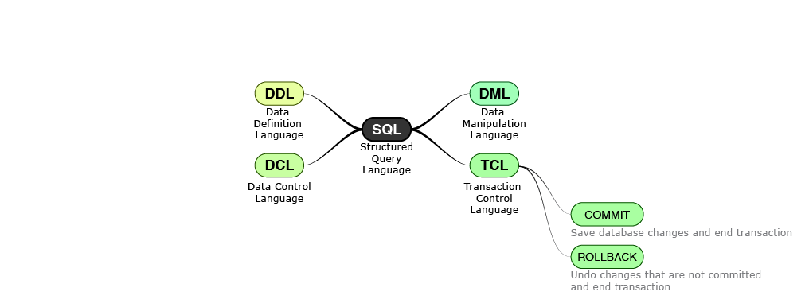

Data Types and Operators
By now we know the overview of SQL and classification of the basic commands, which we will be using in this course to implement our requirements. Before we proceed and start writing the queries, let us understand the commonly used data types and operators of SQL.
In this course we will mainly be discussing the following data types and operators :
Data types :
- Character data types
- Integral data types
- Non-Integral data types
- Miscellaneous data types
Operators :
- Arithmetic operators
- Comparison operators
- Logical operators
Let us discuss these concepts in detail one by one.

Character Data types
SQL supports two character data types for storing printable and displayable characters. They are used for storing information like name, city, description etc.
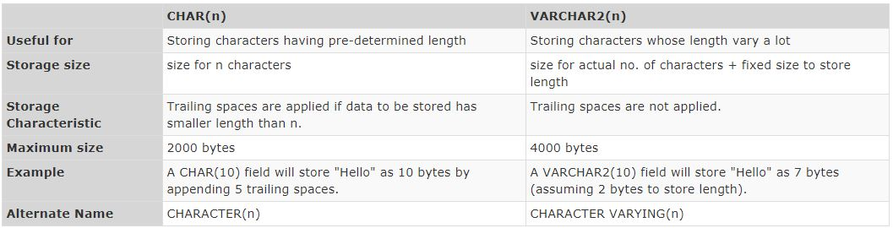

Numeric Data Types
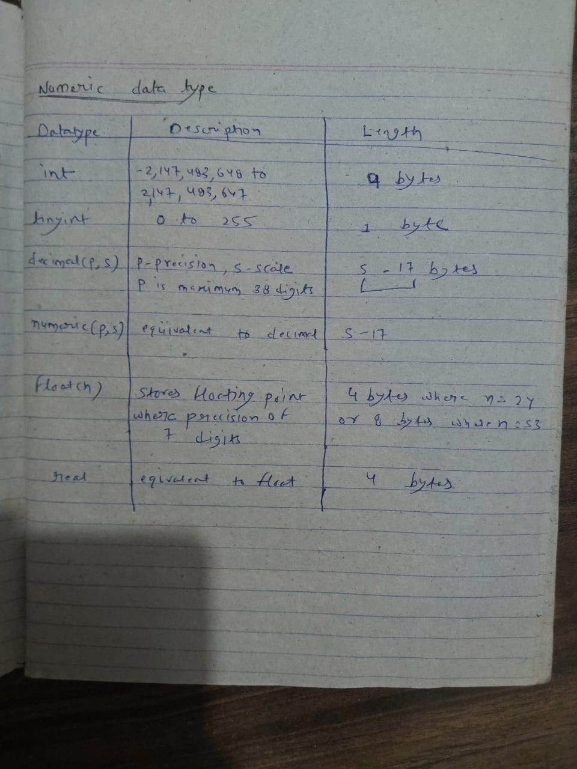

Nonintegral data types have an integer part and a fractional part. Either NUMERIC, DECIMAL or NUMBER data types can be used to store nonintegral numbers.
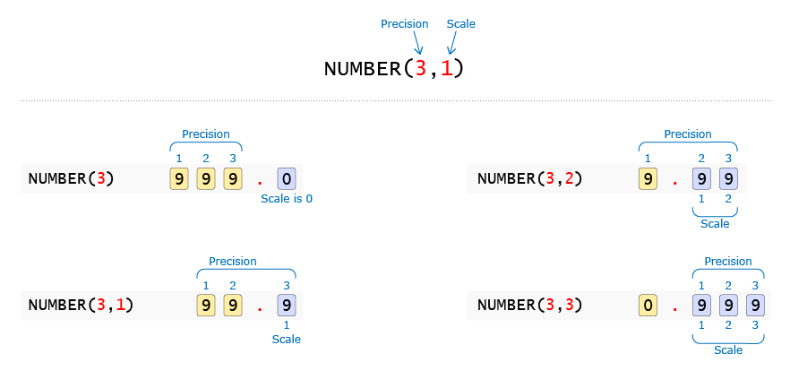
Scale is the number of digits allowed after the decimal point. Precision is the total number of significant digits i.e. digits both before and after the decimal point. If Scale is not provided then NUMBER datatype can be used to store integral values.

Precision and Scale of non-integral data type determines the maximum value that can be stored. It also determines, how input data will be modified before storing the value. We can use the following logic to determine the value that will be stored:
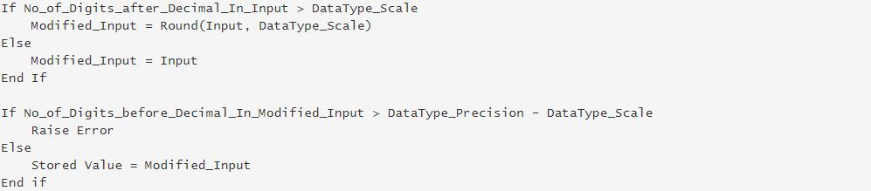
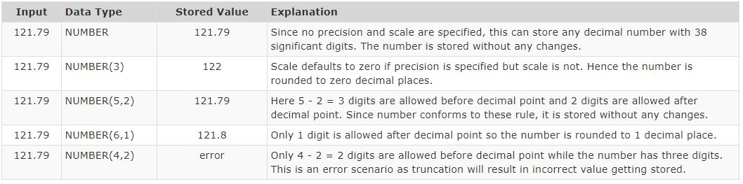

For storing date and large objects, SQL supports the following data types:
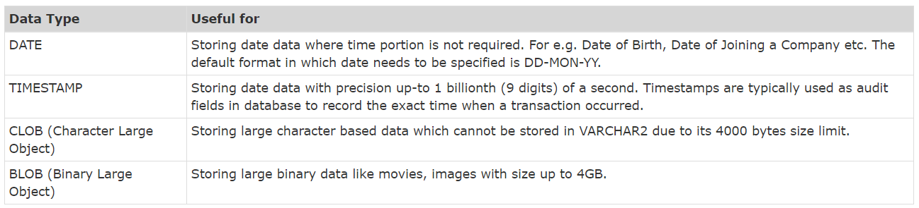

For storing date and large objects, SQL supports the following data types:

Enum data type
An ENUM is a string object whose value is decided from a set of permitted literals(Values) that are explicitly defined at the time of column creation.
Benefits of Enum data type –
- Succinct data storage required to store data in limited size columns. The strings that you pass to the enum data types implicitly get the numerical numbering.
- It also provides readable queries and output easily because the numbers can be translated back to the result of the corresponding string.
- Enum syntax for columns :
- CREATE TABLE table_name (
- col...
- col ENUM ('value_1','value_2','value_3', ....),
- col...
- );

Enum allows null if there is no constraints.
CREATE TABLE Student_grade(
id INT PRIMARY KEY AUTO_INCREMENT, Grade VARCHAR(250) NOT NULL,
priority ENUM('Low', 'Medium', 'High') NOT NULL
);
The prioritized column will accept only three columns. Here, the order of numbering Low->1, Medium->2, High->3
>INSERT INTO Student_grade(Grade, priority)
VALUES('Good grades', 'High');
>INSERT INTO Student_grade(Grade, priority)
VALUES('Poor grades', 1); // can also use number
It isn’t possible to insert more values to the enumerated column. Suppose, you are interested to insert a service-based agreement for every priority e.x., High (48hrs), Medium (4-3 days), Low (1 week), but it is not as easy as it looks and pragmatic with ENUM data type.
Arithmetic Operators
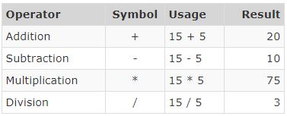

There is one more interger division operator div,it also gives lowes integer values;
>select 5 div 3;
Output - 1

Comparison Operators
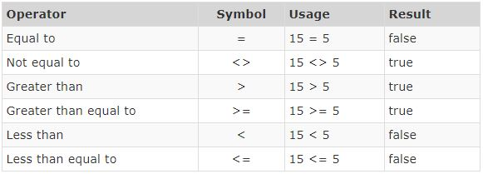
There is one important difference between Equal To comparison operator in programming languages and SQL. While SQL uses a single '=', programming languages typically use double '=' to distinguish it from the assignment operator.
Other Comparison Operators
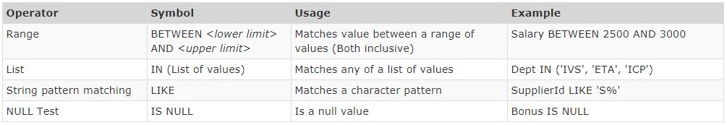

Logical Operators
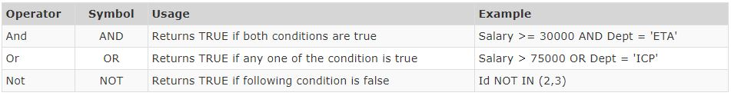

Operator Precedence
Operator | Description
INTERVAL | Return the index of the argument that is less than the first argument
BINARY  COLLATE | This is a type that stores binary byte strings  This clause override whatever the default collation is for comparison
! | Negate values
–  ~ | It change the sign of the operand  It inverts the bits of operand
^ | Bitwise XOR
*  /  DIV  %, MOD | Multiplication operator  Division operator  Integer Division (discard the fractional part of division)  Modulo operator
–  + | Minus operator  Addition operator
<<  >> | Shift a (BIGINT) number or binary string to left  Shift a (BIGINT) number or binary string to right
& | Bitwise AND
| | Bitwise OR
=  <=>  >=, >  <=, <  <>, !=  IS  LIKE  REGEXP  IN | Comparison operator  NULL-safe equal to operator  Greater than/Greater than or equal to  Less than/Less than or equal to  Not Equal to operator  Test a value against a boolean value  Pattern matching operator  Matches the string expression with the regular expression  Check whether a value is present in list or not
BETWEEN  CASE WHEN THEN ELSE | Check whether a value is within a range of values  Case operator
NOT | Negates Value
AND, && | Logical AND
XOR | Logical XOR
OR, || | Logical OR
=  := | Assign a value (as part of a SET statement/SET clause in an UPDATE statement)  Assign a value

Q) Which of the following values can be successfully inserted into a column of datatype NUMBER(4,1)?
i. 99.5
ii 999.98
iii 9999.9
iv 98.47
v 9.7856
i and ii
i, iv and v ANSWER
ii, iii and v
i, iii and iv
i, ii and iv

Set Date as Default
Mysql Date format - YYYY-MM-DD
Get date - > select curdate();
Note- while giving date in values we need to enclose into single quote. Always enclose date in single quote and double quotes. We can use comparison operators i.e. <,> on date datatype.
mysql> create table demo43−> (−> employee_id int not null auto_increment primary key,
−> employee_name varchar(40) not null,
−> employee_status varchar(60) default "NOT JOINED"
,−> employee_joining_date date default(CURRENT_DATE)

Create And Drop Table Synatax
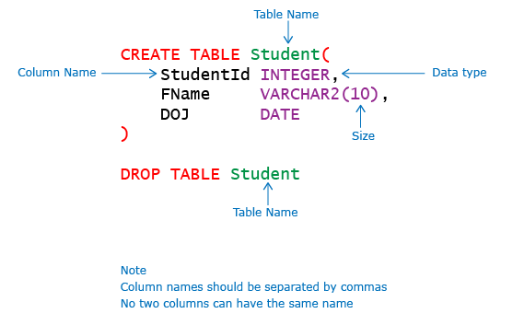

Comment for columns
The comments can be added to the MySQL columns while creating a table by adding the COMMENT keyword after the column definition, as shown above for column emp_name
CREATE TABLE employee_designation(
id int NOT NULL AUTO_INCREMENT,
emp_id int DEFAULT NULL,
emp_name varchar(255) DEFAULT NULL COMMENT "name of employee",
emp_designation varchar(255) DEFAULT NULL,
primary key(id)
);
>SHOW FULL COLUMNS FROM employee_designation ; to see all info.

Engine option in MySQL

While creating a table in MySQL, there are various options that can be specified to add features to the table.
Storage engine in MySQL allows us to define the behavior of the table such as transactional support, referential integrity etc. The ENGINE option decides the storage strategies for table data. Two most commonly used ENGINE classes are MYISAM and INNODB. There are several other storage engines available in MySQL which will be discussed later in this course.

Creating the table using MyISAM Engine:
Using this option, there will be no transactional support such as commit, rollback etc. for the table. All the DML statements executed on the table will be auto-committed by default.
Let us observe this using below example:
- DROP TABLE IF EXISTS USER;
- CREATE TABLE USER(USER_EMAIL varchar(50), USER_NAME varchar(50),
- USER_PHONE bigint(20), USER_PASSWORD varchar(50)) ENGINE=MYISAM;
- INSERT INTO USER VALUES ('visitor1.casperstay@gmail.com','Visitor1',9876543213,'visitor1@123');
- SELECT * FROM USER;
Now let us test the transactional support of ‘MYISAM’ engine by executing the rollback command.
- ROLLBACK;
- SELECT * FROM USER;

Output of the above SELECT query:

As seen above, rollback command has no impact and the row is still available in the table. Hence, transactional operations are not supported in 'MYISAM'.

Creating the table using innodb
Now, we will try executing the same commands using 'INNODB' engine.
- SET AUTOCOMMIT=0;
- DROP TABLE IF EXISTS USER;
- CREATE TABLE USER(USER_EMAIL varchar(50), USER_NAME varchar(50),
- USER_PHONE bigint(20), USER_PASSWORD varchar(50)) ENGINE=INNODB;
- INSERT INTO USER VALUES ('visitor1.casperstay@gmail.com','Visitor1',9876543212,'visitor1@123');
- SELECT * FROM USER;

Conclusion:
‘MYISAM’ does not provide transaction support while ‘INNODB’ has transaction support. We will explore more about these engines in later sections.
Note: 'INNODB' is the default option in the latest version of MySQL when ENGINE is not specified explicitly during table creation.
Next, you will learn about other table options that are available in MySQL

Auto_increment option
here we will discuss about one more frequently used table option called AUTO_INCREMENT. Below is an example how AUTO_INCREMENT can be used to automatically generate the integer values for the primary key column whenever a new record is inserted.Insert into table
- Should be defined as primary key or unique of the table
- Only int is allowed and only one auto_increment is allowed.
CREATE TABLE BOOKING (
BOOKING_ID int(11) PRIMARY KEY AUTO_INCREMENT,
BOOKING_ROOM_ID int(11),
BOOKING_USER_EMAIL varchar(50),
BOOKING_CHECKIN date,
BOOKING_CHECKOUT date,
BOOKING_ROOM_PRICE int(11),
BOOKING_ROOM_RATING int(11),
BOOKING_ROOM__PCOMMENTS varchar(250),
BOOKING_ROOM__NCOMMENTS varchar(250))
ENGINE=InnoDB
AUTO_INCREMENT = 1000;

If value of auto_increment is not provided,it starts with 1.

Update table
> update <tablename> set <columnname> = <value> where condition.
> update employee set salary = 3000 where name = ‘rahul’;
Update statement is used to modify existing rows in a single table in a relational database. Update statement can be represented as:
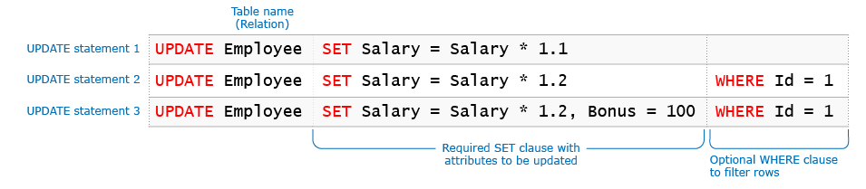
The Update statement fails if the same column is updated multiple times in the same statement.
>UPDATE Employee SET SALARY = 100, SALARY = 200 WHERE ID = 1

Integrity constraint violation in master table
We can’t update the value of master column if those values exist in child table.

Integrity constraint violation in child table
We can update values of child column if those values present in master table.

Delete from table
> delete from employee where name = rahul;
DELETE statement is used to delete records from a single table in a relational database. The database system ensures that no constraints are violated during the execution of a delete statement. Any violation of constraints results in failure of the statement.
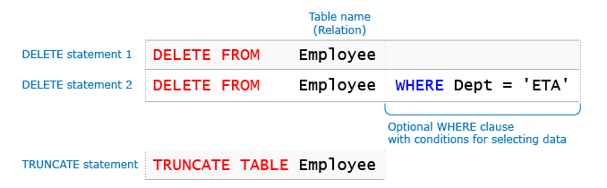

DELETE VS DROP VS TRUNCATE

 | DELETE Command | DROP Command | TRUNCATE Command
Language | The DELETE command is Data Manipulation Language Command. | The DROP command is Data Definition Language Command. | The TRUNCATE command is a Data Definition Language Command.
Use | The DELETE command deletes one or more existing records from the table in the database. | The DROP Command drops the complete table from the database. | The TRUNCATE Command deletes all the rows from the existing table, leaving the row with the column names.
Transition | We can restore any deleted row or multiple rows from the database using the ROLLBACK command. | We cannot get the complete table deleted from the database using the ROLLBACK command. | We cannot restore all the deleted rows from the database using the ROLLBACK command.
Memory Space | The DELETE command does not free the allocated space of the table from memory. | The DROP command removes the space allocated for the table from memory. | The TRUNCATE command does not free the space allocated for the table from memory.
Performance Speed | The DELETE command performs slower than the DROP command and TRUNCATE command as it deletes one or more rows based on a specific condition. | The DROP Command has faster performance than DELETE Command but not as compared to the Truncate Command because the DROP command deletes the table from the database after deleting the rows. | The TRUNCATE command works faster than the DROP command and DELETE command because it deletes all the records from the table without any condition.
Integrity Constraints | The Integrity Constraints remain the same in the DELETE command. | The Integrity Constraints get removed for the DROP command. | The Integrity Constraints will not get removed from the TRUNCATE command.
Permission | DELETE permission is required to delete the rows of the table. | We need ALTER permission on the schema to which the table belongs and CONTROL permission on the table to use the DROP command. | We need table ALTER permission to use the TRUNCATE command.
Syntax | DELETE FROM table_name WHERE condition; | DROP TABLE table_name; | TRUNCATE TABLE table_name;
 | The DELETE statement removes rows one at a time and records an entry in the transaction log for each deleted row. |  | TRUNCATE TABLE removes the data by deallocating the data pages used to store the table data and records only the page deallocations in the transaction log.
 | The identity of the fewer column retains the identity after using DELETE Statement on the table. |  | Identity the column is reset to its seed value if the table contains an identity column

Error Codes
Whenever you perform a database operation for e.g. insert, update etc. you get a status code from the server indicating whether the operation was successful or not and the reason for the failure if any. In addition a descriptive message is also provided. Let us quickly recap on some of the codes you have encountered so far.
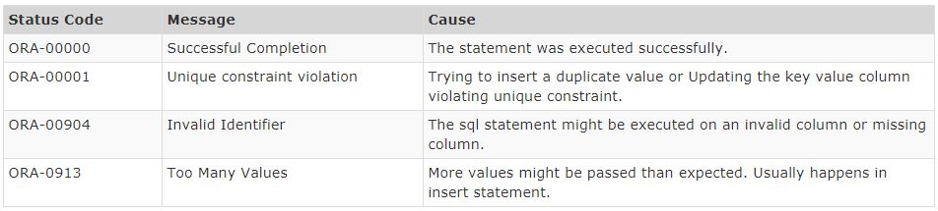
These status codes and messages are published in a reference document. You can refer the link below for Oracle database.
http://docs.oracle.com/cd/E11882_01/server.112/e17766/toc.htm

Constraints
various constraints that can be created on database tables are:
- NOT NULL
- PRIMARY KEY
- CHECK
- UNIQUE
- FOREIGN KEY

We can also specify DEFAULT value for a column. Oracle database does not consider DEFAULT as a constraint.

Ways of creating Constraints
- Column label
- Table label

> create table t(empid integer primary key,name varchar(5)) // column lable
> create table t(empid integer,name varchar(5) , constraint <any name> primary key(empid)) // table lable . in this constraint name is optional.

One disadvantage of column label is that we can not include multiple column to form a primary key

Not Null constraint
NOT NULL Constraint prevents a column from accepting NULL values. NOT NULL can only be applied as a column level constraint. Constraint name is optional and it can be specified by using CONSTRAINT keyword
Not Null constraint can not be applied on table label,because there is no use of merging two column for not null.

> Create table marks(name integer Not Null,id varchar(10) );

Default Constraint
Here’s the syntax to add default constraint using CREATE table statement.
mysql> create table table_name(
column1 column1_definition DEFAULT default_value,
column2 column2_definition,
...
);
In the above SQL query, you need to specify the table name table_name. Also, you need to mention DEFAULT after the column definition of the field for which you want to add default value. You need to also specify the default value of your column.

Primary Key Constraint
PRIMARY KEY constraint on a column ensures that the column cannot contain NULL and duplicate values. We can have only one PRIMARY KEY in a table.

> create table t(id int primary key,name varchar(10)); // column lable
> create table t(id int,name varchar(10), constraint pk primary key(id)); // table lable

Check Constraint
The following SQL creates a CHECK constraint on the "Age" column when the "Persons" table is created. The CHECK constraint ensures that the age of a person must be 18, or older:
CREATE TABLE Persons (
ID int NOT NULL,
LastName varchar(255) NOT NULL,
FirstName varchar(255),
Age int,
CHECK (Age>=18)
);
To allow naming of a CHECK constraint, and for defining a CHECK constraint on multiple columns, use the following SQL syntax:
CREATE TABLE Persons (
ID int NOT NULL,
LastName varchar(255) NOT NULL,
FirstName varchar(255),
Age int,
City varchar(255),
CONSTRAINT CHK_Person CHECK (Age>=18 AND City='Sandnes')
);

CREATE TABLE Student (
StudentId INTEGER,
FName VARCHAR2(10),
Gender CHAR(1) CONSTRAINT Stud_gender_ck1 CHECK(Gender IN('M', 'F')));

SQL UNIQUE Constraint
The UNIQUE constraint ensures that all values in a column are different.
Both the UNIQUE and PRIMARY KEY constraints provide a guarantee for uniqueness for a column or set of columns.
A PRIMARY KEY constraint automatically has a UNIQUE constraint.
However, you can have many UNIQUE constraints per table, but only one PRIMARY KEY constraint per table.
SQL UNIQUE Constraint on CREATE TABLE
The following SQL creates a UNIQUE constraint on the "ID" column when the "Persons" table is created:
SQL Server / Oracle / MS Access:
CREATE TABLE Persons (
ID int NOT NULL UNIQUE,
LastName varchar(255) NOT NULL,
FirstName varchar(255),
Age int
);
MySQL:
CREATE TABLE Persons (
ID int NOT NULL,
LastName varchar(255) NOT NULL,
FirstName varchar(255),
Age int,
UNIQUE (ID)
);
To name a UNIQUE constraint, and to define a UNIQUE constraint on multiple columns, use the following SQL syntax:
MySQL / SQL Server / Oracle / MS Access:
CREATE TABLE Persons (
ID int NOT NULL,
LastName varchar(255) NOT NULL,
FirstName varchar(255),
Age int,
CONSTRAINT UC_Person UNIQUE (ID,LastName)
);

Foreign Key Constraint
Foreign key is reference to any unique or primary key column to another table.
MySQL:
CREATE TABLE Orders (
OrderID int NOT NULL,
OrderNumber int NOT NULL,
PersonID int,
PRIMARY KEY (OrderID),
FOREIGN KEY (PersonID) REFERENCES Persons(PersonID)
);

OR
CREATE TABLE ORDERS(PERSONID INT REFERENCES PERSONS(PERSONID)) // COLLUMN LABEL

Constraint Summary
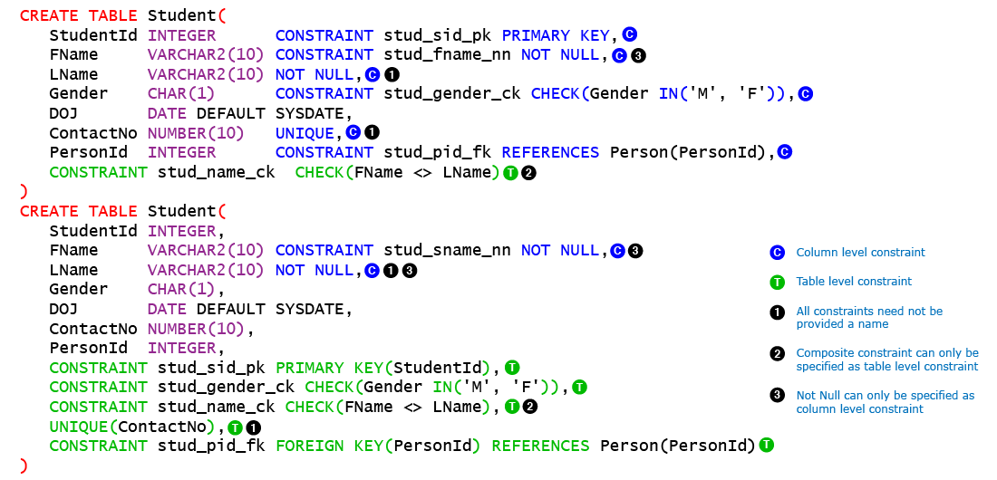

ALTER Table
We need to use ALTER TABLE command through which the structure of the existing table can be changed without any loss of data. It can also be used to rename a column, change the data type of a column and to add or remove constraints.
Syntax for ALTER TABLE command is provided below:
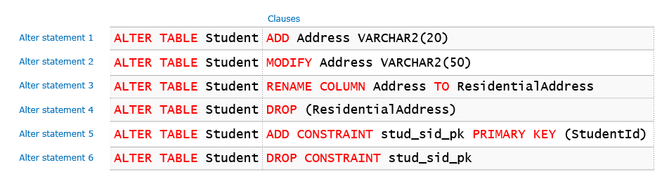
To drop multiple column in mysql
>ALTER TABLE TableName
> DROP Column1,
>DROP Column2;

In mysql we can not drop all columns.one columns must be present in table.

Mysql Drop Constraint
In mysql There is no Drop Constraint,instead we use
MySQL:
ALTER TABLE Persons
DROP PRIMARY KEY;

MySQL:
ALTER TABLE Orders
DROP FOREIGN KEY FK_PersonOrder;
MySQL:
ALTER TABLE Persons
DROP CHECK CHK_PersonAge;

Insert into table
Insert statement is used to add tuples (records) to the table. It supports three alternate syntaxes as shown below:
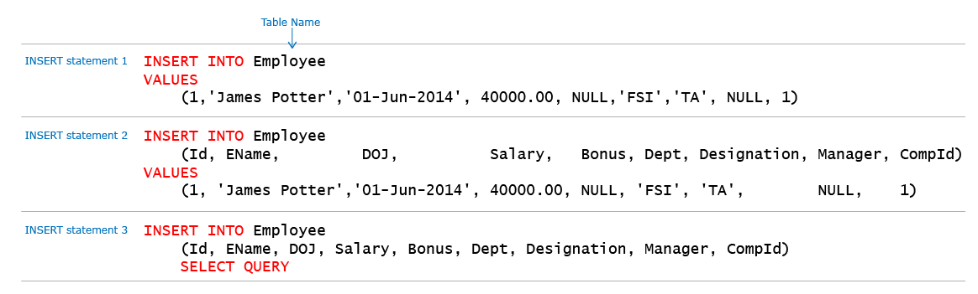
If column names are not used then values must be provided for all columns in the order of their specification during table creation.
If column names are used then the data provided in the values clause must have the same data type of column at same position.
Multiple rows can be inserted through a single INSERT statement only when it is used with SELECT statement. You will learn about SELECT QUERY shortly.
While inserting data, column values should match column type definition(e.g., you can’t insert a textual value into the numerical column/attribute). If the column is of strings or date time or characters, they need to be enclosed in single quotes(You cannot use double quotes). String data is case sensitive and will be stored as given within quotes. If the data is numeric, you don't need the quotes. NULL also should not be enclosed with quotes.

Select Statement
Select is the most commonly used statement in SQL. The SELECT Statement in SQL is used to retrieve or fetch data from a database. We can fetch either the entire table or according to some specified rules. The data returned is stored in a result table. This result table is also called the result-set.
With the SELECT clause of a SELECT command statement, we specify the columns that we want to be displayed in the query result and, optionally, which column headings we prefer to see above the result table.
Simple SELECT statements can be represented as:

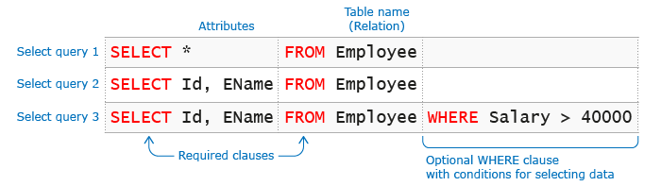

Aliasing in Select
>SELECT Id EmpId, EName EmpName, Salary FROM Employee
> Select id as Empid from employee

Both are correct way for aliasing.

Alias with space
If Alias contains spaces then we need to use single quote or double quotes
> select id as ‘school id’ from employee;

Expression in Select
>SELECT EName, Salary * 2 AS Double_Salary FROM Employee

Constant
SELECT EName, 30 AS Value FROM Employee
ENAME | VALUE
James Potter | 30
Ethan McCarty | 30
Emily Rayner | 30
Jack Abraham | 30

Distinct in Select

On Single Column
>SELECT DISTINCT Dept FROM Employee
// DISTINCT does not includes null.

Multiple Column
If DISTINCT is used with multiple columns then two rows are considered equal only if all their columns match.
>SELECT DISTINCT Dept, Manager FROM EMPLOYEE

Incorrect Usage
DISTINCT must be used immediately after SELECT. Any attempt to use it between columns will result in error.
>SELECT Dept, DISTINCT Manager FROM EMPLOYEE
ORA-00936: missing expression
As expected error occurs
We can use distinct in count() anywhere in the query.

If table has multiple null values then distinct give only one null value.

Is it mandatory for alias of a column to have a name different than the name of column being aliased?

Ans - No , we can use same name or even same name for multiple columns.

Where Cluase

>SELECT ID, ENAME FROM Employee WHERE SALARY >= 30000 AND DEPT = 'ETA'
>SELECT ID, ENAME FROM Employee WHERE SALARY BETWEEN 30000 and 50000 // both values are inclusive

If the WHERE clause has multiple conditions on the same column name then it has to be specified in each condition. Shortcut version allowed by some languages is not permitted.
>SELECT ID, EName FROM Employee WHERE Designation = 'PM' OR 'SE'
ORA-00920: invalid relational operator
The query fails as the column name for the second condition in WHERE clause is not specified.

IN operator
IN operator is used to check for multiple values of an attribute. It is equivalent to OR operation on multiple equality condition on the attribute on individual values.
>SELECT ID, ENAME FROM Employee WHERE ID IN (2,3)
>SELECT ID, ENAME FROM Employee WHERE DEPT IN ('ETA', 'ETA') // duplicates allowed

>SELECT ID, ENAME FROM Employee WHERE ID NOT IN (2,3)

Is Null operator
Equal to operator cannot be used to check for NULL values
>SELECT ID, EName FROM Employee WHERE BONUS = NULL // return empty set
>SELECT ID, EName FROM Employee WHERE BONUS IS NULL // return null values
>SELECT ID, EName FROM Employee WHERE BONUS IS NOT NULL

If NULL is used with IN clause then the condition behavior is similar to = NULL (not is NULL)
>SELECT ID, ENAME FROM Employee WHERE BONUS IN (NULL) // return empty set

Where with Char and Varchar
CHAR data types are stored with trailing spaces. While filtering them using equality operator you need not provide trailing spaces.
>SELECT Id, EName, Designation FROM Employee WHERE Designation = 'PM' // fetch all the records with PM stored into them.

Trailing spaces are ignored for CHAR data type.
>SELECT Id, EName, Designation FROM Employee WHERE Designation = 'PM ' // give the same result as previous.

Leading spaces are not ignored for CHAR data type. If you use them you will not fetch any records.
>>SELECT Id, EName, Designation FROM Employee WHERE Designation = ' PM'

窗体顶端
trailing spaces and leading spaces are not ignored for VARCHAR2 data type.
>SELECT Id, EName, Designation FROM Employee WHERE EName = 'James Potter ' // if will fetch only exactyl mathching records including spaces also.
窗体底端

Like operator
LIKE operator is used to match a character pattern. It allows us to use wild cards. SQL supports two wild cards: '%' which matches with any number of characters and '_' which matches with exactly one character.
>SELECT ID, ENAME FROM Employee WHERE ENAME LIKE 'E%'
// Displays those rows where name begins with character 'E' followed by any number of characters.

>SELECT ID, ENAME FROM Employee WHERE ENAME LIKE '%m%' // it matches ‘m’ anywhere.
Output
ID | ENAME
1 | James Potter
3 | Emily Rayner
4 | Jack Abraham
5 | Ayaz Mohammad

>SELECT ID, ENAME, DOJ FROM Employee WHERE DOJ LIKE '__-___-__'
Output
ID | ENAME | DOJ
1 | James Potter | 01-Jun-14
2 | Ethan McCarty | 01-Feb-14
3 | Emily Rayner | 01-Jan-14
4 | Jack Abraham | 01-Jul-14
5 | Ayaz Mohammad | 01-Apr-14

Order of Query Exuecution
A SELECT statement can have many clauses so it is important to understand the order in which these are executed to provide the result. However, for ease of understanding we can refer to the execution order by FJWGHSDO.
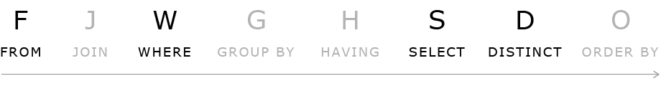
A quick way to remember this is to use the mnemonic "Frank John's Wicked Grave Haunts Several Dull Owls". In this section we will focus on FROM, WHERE, SELECT and DISTINCT keywords.
>select fee as newfees from registration order by newfees; // it gives error because ‘where’ executed before ‘select’.
>select fee*10 as newfees from registration order by newfees; // it wil be executed succesfully because ‘order by’ executed after ‘select’. but in order by we can also use column which are present in table but not present in select.
Execution Examples
https://lex.infosysapps.com/web/en/viewer/web-module/lex_auth_0127540039375831042109?collectionId=lex_auth_01275806667282022456&collectionType=Course&pathId=lex_auth_0130086059766251521298

https://lex.infosysapps.com/web/en/viewer/web-module/lex_auth_0127540039375831042109?collectionId=lex_auth_01275806667282022456&collectionType=Course&pathId=lex_auth_0130086059766251521298

MYSQL Pattern Matching
MySQL supports another type of pattern matching operation based on the regular expressions and the REGEXP operator.
- It provide a powerful and flexible pattern match that can help us implement power search utilities for our database systems.
- REGEXP is the operator used when performing regular expression pattern matches. RLIKE is the synonym.
- It also supports a number of metacharacters which allow more flexibility and control when performing pattern matching.
- The backslash is used as an escape character. It’s only considered in the pattern match if double backslashes have used.
- Not case sensitive.
Pattern | What the Pattern matches
* | Zero or more instances of string preceding it
+ | One or more instances of strings preceding it
. | Any single character
? | Match zero or one instances of the strings preceding it.
^ | caret(^) matches Beginning of string
$ | End of string
[abc] | Any character listed between the square brackets
[^abc] | Any character not listed between the square brackets
[A-Z] | match any upper case letter.
[a-z] | match any lower case letter
[0-9] | match any digit from 0 through to 9.
[[:<:]] | matches the beginning of words.
[[:>:]] | matches the end of words.
[:class:] | matches a character class i.e. [:alpha:] to match letters, [:space:] to match white space, [:punct:] is match punctuations and [:upper:] for upper class letters.
p1|p2|p3 | Alternation; matches any of the patterns p1, p2, or p3
{n} | n instances of preceding element
{m,n} | m through n instances of preceding element
Examples with explanation :
- Match beginning of string(^): Gives all the names starting with ‘sa’.Example- sam,samarth.
SELECT name FROM student_tbl WHERE name REGEXP '^sa';
- Match the end of a string($): Gives all the names ending with ‘on’.Example – norton,merton.
SELECT name FROM student_tbl WHERE name REGEXP 'on$';
- Match zero or one instance of the strings preceding it(?): Gives all the titles containing ‘com’.Example – comedy , romantic comedy.
SELECT title FROM movies_tbl WHERE title REGEXP 'com?';
- matches any of the patterns p1, p2, or p3(p1|p2|p3): Gives all the names containing ‘be’ or ‘ae’.Example – Abel, Baer.
SELECT name FROM student_tbl WHERE name REGEXP 'be|ae' ;
- Matches any character listed between the square brackets([abc]): Gives all the names containing ‘j’ or ‘z’.Example – Lorentz, Rajs.
SELECT name FROM student_tbl WHERE name REGEXP '[jz]' ;
- Matches any lower case letter between ‘a’ to ‘z’- ([a-z]) ([a-z] and (.)): Retrieve all names that contain a letter in the range of ‘b’ and ‘g’, followed by any character, followed by the letter ‘a’.Example – Tobias, sewall. Matches any single character(.)
SELECT name FROM student_tbl WHERE name REGEXP '[b-g].[a]' ;
- Matches any character not listed between the square brackets.([^abc]): Gives all the names not containing ‘j’ or ‘z’. Example – nerton, sewall.
SELECT name FROM student_tbl WHERE name REGEXP '[^jz]' ;
- Matches the end of words[[:>:]]: Gives all the titles ending with character “ack”. Example – Black.
SELECT title FROM movies_tbl WHERE REGEXP 'ack[[:>:]]';
- Matches the beginning of words[[:<:]]: Gives all the titles starting with character “for”. Example – Forgetting Sarah Marshal.
SELECT title FROM movies_tbl WHERE title REGEXP '[[:<:]]for';
- Matches a character class[:class:]: i.e [:lower:]- lowercase character ,[:digit:] – digit characters etc. Gives all the titles containing alphabetic character only. Example – stranger things, Avengers.
SELECT title FROM movies_tbl WHERE REGEXP '[:alpha:]' ;
- Matches the beginning of all words by any character listed between the square brackets.(^[abc]): Gives all the names starting with ‘n’ or ‘s’. Example – nerton, sewall.
SELECT name FROM student_tbl WHERE name REGEXP '^[ns]' ;

Function in Mysql
By now, we have learnt how to write queries to fetch the required information from a table. Let us discuss different types of functions with examples.
SQL provides many built-in functions in order to accomplish many tasks. Some of the commonly used built-in functions are:

- Numeric functions
- Character functions
- Conversion functions
- Date functions
- Aggregate functions

Along with these functions, we are also going to see some of the Miscellaneous functions.
While multi-row functions are common across databases, each database provides a set of single-row functions to operate on the data. In this course, you will learn about some of the single-row functions provided in Oracle database.
SQL functions are built in modules provided by a database. You can use them in data manipulation statements to perform calculations on data.
All functions return a single value. They are categorized into two types based on number of rows they operate upon.
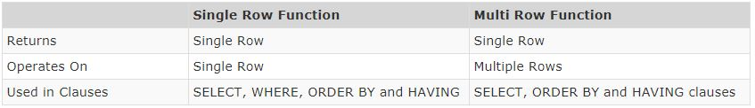
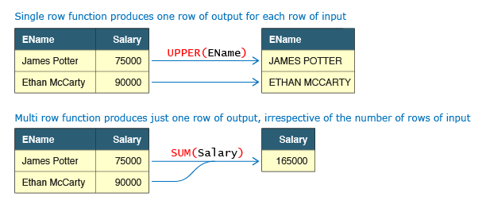

Numeric Functions
Numeric functions are single row functions that accept a numeric value and return numeric output.
Name | Syntax | Function
ABS | ABS(value) | Returns absolute value of a number
ROUND | ROUND(value, digits) | Rounds the value to specified decimal digits
CEIL | CEIL(value) | Rounds up the fractional value to next integer
FLOOR | FLOOR(value) | Rounds down the fractional value to the lower integer

Character Functions
Name | Syntax | Function
UPPER | UPPER(value) | Converts value to upper case
LOWER | LOWER(value) | Converts value in lower case
CONCAT | CONCAT(value1, value2) | Concatenates value1 and value2, valueN
LENGTH | LENGTH(value) | Returns the number of characters in value.

Substr function
Substring function is used to extract part of a string. It has the following syntax SUBSTR(value, start_position, length)
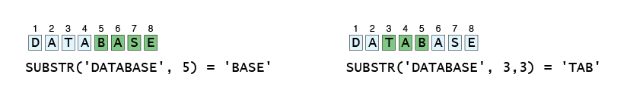

Replace()
The REPLACE() function replaces all occurrences of a substring within a string, with a new substring.
Note: This function performs a case-sensitive replacement.
REPLACE(string, from_string, new_string)
>SELECT REPLACE("XYZ FGH XYZ", "X", "M");
>select ceil(avg(salary) - avg(replace(salary,0,''))) from employees;

Conversion functions
- Convert()
- Cast()

Convert()
Here are the steps to convert data in MySQL using MySQL CONVERT function. Here’s the syntax of MySQL CONVERT function
CONVERT(input_value, data_type)
In the above function, you need to provide input_value as literal string or column name, and data_type to which you want to convert this data. Like MySQL CAST, you can cast data into BINARY, CHAR, DATE, DATETIME, TIME, DECIMAL, SIGNED, UNSIGNED data types.
mysql> select convert('1.234',decimal(4,3));
+-------------------------------+
| convert('1.234',decimal(4,3)) |
+-------------------------------+
| 1.234 |
+-------------------------------+

mysql> select convert('2020-08-01 13:00:00',date);
+-------------------------------------+
| convert('2020-08-01 13:00:00',date) |
+-------------------------------------+
| 2020-08-01 |
+-------------------------------------+

Cast()
We will look at how MySQL CAST works and how to typecast data using MySQL CAST function.
Here’s the syntax of MySQL CAST function
CAST(data as data_type)
MySQL CAST requires two inputs – the data to be typecasted and the data type (decimal, char, etc) to which you want to convert this data. You can cast data into BINARY, CHAR, DATE, DATETIME, TIME, DECIMAL, SIGNED, UNSIGNED data types.
mysql> select cast(1.23 as decimal(4,3));
+----------------------------+
| cast(1.23 as decimal(4,3)) |
+----------------------------+
| 1.230 |

mysql> select cast('xyz' as char);
+---------------------+
| cast('xyz' as char) |
+---------------------+
| xyz |

Date and Time Functions
Functions | Description
ADDDATE() | MySQL ADDDATE() adds a time value with a date.
ADDTIME() | In MySQL the ADDTIME() returns a time or datetime after adding a time value with a time or datetime.
CONVERT_TZ() | In MySQL the CONVERT_TZ() returns a resulting value after converting a datetime value from a time zone specified as the second argument to the time zone specified as the third argument.
CURDATE() | In MySQL the CURDATE() returns the current date in 'YYYY-MM-DD' format or 'YYYYMMDD' format depending on whether numeric or string is used in the function.
CURRENT_DATE() | In MySQL the CURRENT_DATE returns the current date in ‘YYYY-MM-DD’ format or YYYYMMDD format depending on whether numeric or string is used in the function.
CURRENT_TIME() | In MySQL the CURRENT_TIME() returns the current time in ‘HH:MM:SS’ format or HHMMSS.uuuuuu format depending on whether numeric or string is used in the function.
CURRENT_TIMESTAMP() | In MySQL the CURRENT_TIEMSTAMP returns the current date and time in ‘YYYY-MM-DD HH:MM:SS’ format or YYYYMMDDHHMMSS.uuuuuu format depending on whether numeric or string is used in the function.
CURTIME() | In MySQL the CURTIME() returns the value of current time in ‘HH:MM:SS’ format or HHMMSS.uuuuuu format depending on whether numeric or string is used in the function.
DATE_ADD() | MySQL DATE_ADD() adds time values (as intervals) to a date value. The ADDDATE() is the synonym of DATE_ADD().
DATE_FORMAT() | MySQL DATE_FORMAT() formats a date as specified in the argument. A list of format specifiers given bellow may be used to format a date.
DATE_SUB() | MySql date_sub() function subtract a time value (as interval) from a date.
DATE() | MySQL DATE() takes the date part out from a datetime expression.
DATEDIFF() | MySQL DATEDIFF() returns the number of days between two dates or datetimes.
DAY() | MySQL DAY() returns the day of the month for a specified date.
DAYNAME() | MySQL DAYNAME() returns the name of the week day of a date specified in the argument.
DAY OF MONTH() | MySQL DAYOFMONTH() returns the day of the month for a given date.
DAY OF WEEK() | MySQL DAYOFWEEK() returns the week day number (1 for Sunday,2 for Monday …… 7 for Saturday ) for a date specified as an argument.
DAY OF YEAR() | MySQL DAYOFYEAR() returns day of the year for a date. The return value is within the range of 1 to 366.
EXTRACT() | MySQL EXTRACT() extracts a part of a given date.
FROM_DAYS() | MySQL FROM_DAYS() returns a date against a datevalue.
FROM_UNIXTIME() | MySQL FROM_UNIXTIME() returns a date /datetime from a version of unix_timestamp.
GET_FORMAT() | MySQL GET_FORMAT() converts a date or time or datetime in a formatted manner as specified in the argument.
HOUR() | MySQL HOUR() returns the hour of a time.
LAST_DAY() | MySQL LAST_DAY() returns the last day of the corresponding month for a date or datetime value.
LOCALTIME() | MySQL LOCALTIME returns the value of current date and time in ‘YYYY-MM-DD HH:MM:SS’ format or YYYYMMDDHHMMSS.uuuuuu format depending on the context (numeric or string) of the function.
LOCALTIMESTAMP() | MySQL LOCALTIMESTAMP returns the value of current date and time in ‘YYYY-MM-DD HH:MM:SS’ format or YYYMMDDHHMMSS.uuuuuu format depending on the context (numeric or string) of the function.
MAKEDATE() | MySQL MAKEDATE() returns a date by taking a value of a year and a number of days. The number of days must be greater than 0 otherwise a NULL will be returned.
MAKETIME() | MySQL MAKETIME() makes and returns a time value from a given hour, minute and seconds.
MICROSECOND() | MySQL MICROSECOND() returns microseconds from the time or datetime expression.
MINUTE() | MySQL MINUTE() returns a minute from a time or datetime value.
MONTH() | MySQL MONTH() returns the month for the date within a range of 1 to 12 ( January to December).
MONTHNAME() | MySQL MONTHNAME() returns the full name of the month for a given date.
NOW() | MySQL NOW() returns the value of current date and time in ‘YYYY-MM-DD HH:MM:SS’ format or YYYYMMDDHHMMSS.uuuuuu format depending on the context (numeric or string) of the function.
PERIOD_ADD() | MySQL PERIOD_ADD() adds a number of months with a period and returns the value in the format YYYYMM OR YYMM. Remember that the format YYYYMM and YYMM are not date values.
PERIOD_DIFF() | MySQL PERIOD_DIFF() returns the difference between two periods.
QUARTER() | MySQL QUARTER() returns the quarter of the year for a date.
SEC_TO_TIME() | MySQL SEC_TO_TIME() returns a time value by converting the seconds specified in the argument.
SECOND() | MySQL SECOND() returns the second for a time.
STR_TO_DATE() | MySQL STR_TO_DATE() returns a datetime value by taking a string and a specific format string as arguments.
SUBDATE() | MySQL SUBDATAE() subtracts a time value (as interval) from a given date.
SUBTIME() | MySQL SUBTIME() subtracts one datetime value from another.
SYSDATE() | MySQL SYSDATE() returns the current date and time in YYYY-MM-DD HH:MM:SS or YYYYMMDDHHMMSS.uuuuuu format depending on the context of the function.
TIME_FORMAT() | MySQL TIME_FORMAT() converts a time in a formatted string using the format specifiers.
TIME_TO_SEC() | MySQL TIME_TO_SEC() converts a time value in to seconds.
TIME() | MySQL TIME() extracts the time part of a time or datetime expression as string format.
TIMEDIFF() | MySQL TIMEDIFF() returns the differences between two time or datetime expressions.
TIMESTAMP() | MySQL TIMESTAMP() returns a datetime value against a date or datetime expression.
TIMESTAMPADD() | MySQL TIMESTAMPADD() adds time value with a date or datetime value.
TIMESTAMPDIFF() | MySQL the TIMESTAMPDIFF() returns a value after subtracting a datetime expression from another.
TO_DAYS() | MySQL TO_DAYS() returns number of days between a given date and year 0.
UNIX_TIMESTAMP() | MySQL UNIX_TIMESTAMP() returns a Unix timestamp in seconds since '1970-01-01 00:00:00' UTC as an unsigned integer if no arguments are passed with UNIT_TIMESTAMP().
UTC_DATE() | MySQL UTC_DATE returns the current UTC (Coordinated Universal Time) date as a value in 'YYYY-MM-DD' or YYYYMMDD format depending on the context of the function i.e. in a string or numeric context.
UTC_TIME() | MySQL UTC_TIME returns the current UTC time as a value in 'HH:MM:SS' or HHMMSS format depending on the context of the function i.e. in a string or numeric context.
UTC_TIMESTAMP() | In MySQL the UTC_TIMESTAMP returns the current UTC date and time as a value in 'YYYY-MM-DD HH:MM:SS' or YYYYMMDDHHMMSS.uuuuuu format depending on the usage of the function i.e. in a string or numeric context.
WEEK() | MySQL WEEK() returns the week number for a given date.
WEEKDAY() | MySQL WEEKDAY() returns the index of the day in a week for a given date (0 for Monday, 1 for Tuesday and ......6 for Sunday).
WEEK OF YEAR() | MySQL WEEKOFYEAR() returns the calender week (as a number) of a given date.
YEAR() | MySQL YEAR() returns the year for a given date.
YEARWEEK() | MySQL YEARWEEK() returns year and week number for a given date.

For more details
https://www.w3resource.com/mysql/date-and-time-functions/date-and-time-functions.php

Date_format(date,’specifier)
Specifier | Meaning
%a | Three-characters abbreviated weekday name e.g., Mon, Tue, Wed, etc.
%b | Three-characters abbreviated month name e.g., Jan, Feb, Mar, etc.
%c | Month in numeric e.g., 1, 2, 3…12
%D | Day of the month with English suffix e.g., 0th, 1st, 2nd, etc.
%d | Day of the month with leading zero if it is 1 number e.g., 00, 01,02, …31
%e | Day of the month without leading zero e.g., 1,2,…31
%f | Microseconds in the range of 000000..999999
%H | Hour in 24-hour format with leading zero e.g., 00..23
%h | Hour in 12-hour format with leading zero e.g., 01, 02…12
%I | Same as %h
%i | Minutes with leading zero e.g., 00, 01,…59
%j | Day of year with leading zero e.g., 001,002,…366
%k | Hour in 24-hour format without leading zero e.g., 0,1,2…23
%l | Hour in 12-hour format without leading zero e.g., 1,2…12
%M | Full month name e.g., January, February,…December
%m | Month name with leading zero e.g., 00,01,02,…12
%p | AM or PM, depending on other time specifiers
%r | Time in 12-hour format hh:mm:ss AM or PM
%S | Seconds with leading zero 00,01,…59
%s | Same as %S
%T | Time in 24-hour format hh:mm:ss
%U | Week number with leading zero when the first day of week is Sunday e.g., 00,01,02…53
%u | Week number with leading zero when the first day of week is Monday e.g., 00,01,02…53
%V | Same as %U; it is used with %X
%v | Same as %u; it is used with %x
%W | Full name of weekday e.g., Sunday, Monday,…, Saturday
%w | Weekday in number (0=Sunday, 1= Monday,etc.)
%X | Year for the week in four digits where the first day of the week is Sunday; often used with %V
%x | Year for the week, where the first day of the week is Monday, four digits; used with %v
%Y | Four digits year e.g., 2000 and 2001.
%y | Two digits year e.g., 10,11,and 12.
%% | Add percentage (%) character to the output

Aggregate Functions
Aggregate functions operate on multiple rows to return a single row. Some aggregate functions like SUM (total), AVG (average) operates only on numeric columns while others like MIN (lowest value), MAX (highest value) and COUNT (number of rows) operate on all data types. All aggregate functions ignore NULL values except COUNT(*).

Count with Distinct
Use DISTINCT with COUNT function to get a count of unique values for a column. Similary DISTINCT can also be used with other aggregate functions.
>SELECT COUNT(Dept) Count1, COUNT(DISTINCT Dept) Count2 FROM Employee

Aggregate functions cannot be used in WHERE clause.
>SELECT Id, EName, Salary, Dept FROM Employee E1 WHERE Salary = MAX(Salary)

ORA-00934: group function is not allowed here
The query fails as MAX function is used in WHERE clause.

Miscellaneous function

coalesce
coalesce(value1 or col1, value2 or col2,values3,..,valueN)Substitutes value1 by value2 if value1 is NULL and so on.

GREATEST and LEAST Function
The SQL GREATEST function returns the “greatest” or largest value in a set of values that you provide to it.
The SQL LEAST function returns the “least” or smallest value in a set of values that you provide to it, and it’s the opposite of the GREATEST function.

SELECT LEAST(from_id,to_id) as person1,
GREATEST(from_id,to_id) as person2,
COUNT(*) as call_count,
SUM(duration) as total_duration
FROM Calls
GROUP BY person1,person2;

Current_user()
>select current_user() // returns current logged in user.

Case Statement

CASE statement can be used in SELECT clause to conditionally assign values to a computed attribute. It can also be used with WHERE, GROUP BY etc. CASE statement has two different syntax styles: Simple CASE expression and Searched CASE expression. Both of them are similar to if else statement in Java.

Simple CASE expression :
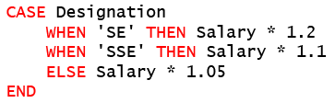
Pseudo code:
if designation == 'SE'
salary = salary * 1.2
else if designation == 'SSE'
salary = salary * 1.1
else
salary = salary * 1.05
The CASE statement goes through conditions and returns a value when the first condition is met (like an IF-THEN-ELSE statement). So, once a condition is true, it will stop reading and return the result. If no conditions are true, it returns the value in the ELSE clause.
SELECT Id, EName, Designation, Salary,
CASE Designation
WHEN 'SE' THEN Salary * 1.2
WHEN 'SSE' THEN Salary * 1.1
ELSE Salary * 1.05
END New_Salary
FROM Employee;
ID | ENAME | DESIGNATION | SALARY | NEW_SALARY
1 | James Potter | PM | 75000 | 78750
2 | Ethan McCarty | PM | 90000 | 94500
3 | Emily Rayner | SE | 25000 | 30000
4 | Jack Abraham | SSE | 30000 | 33000
5 | Ayaz Mohammad | TA | 40000 | 42000

Searched CASE expression :
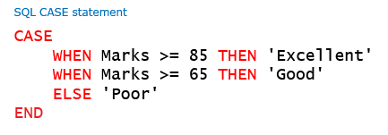

Pseudo code:
if marks >= 85
grade = 'Excellent'
else if marks >= 65
grade = 'Good'
else
grade = 'Poor'
We can use the second syntax form to compare different conditions.
NOTE: ELSE is optional. If ELSE is omitted and no condition is true, then NULL is returned by CASE.

SELECT OrderID, Quantity,
CASE WHEN Quantity > 30 THEN 'The quantity is greater than 30'
WHEN Quantity = 30 THEN 'The quantity is 30'
ELSE 'The quantity is under 30'
END AS QuantityText
FROM OrderDetails;

OrderID | Quantity | QuantityText
10248 | 12 | The quantity is under 30
10248 | 10 | The quantity is under 30
10248 | 5 | The quantity is under 30
10249 | 9 | The quantity is under 30
10249 | 40 | The quantity is greater than 30
10250 | 10 | The quantity is under 30
10250 | 35 | The quantity is greater than 30

SELECT CustomerName, City, Country
FROM Customers
ORDER BY
(CASE
WHEN City IS NULL THEN Country
ELSE City
END);

Multiple conditions
SELECT Id, EName, Designation, Salary,
CASE
WHEN Designation = 'SE' OR Designation = 'SSE' THEN TO_CHAR(Salary * 1.2)
WHEN Designation = 'PM' AND Salary >= 90000 THEN 'No hike'
ELSE TO_CHAR(Salary * 1.05 )
END New_Salary

Order by
Order By clause is used to sort the result of a query in a particular order. Before we understand the syntax of ORDER BY, let us understand the sorting process on tabular data. Data in a single column can be sorted in ascending or descending order.
We can also sort data by multiple columns. In such case data is sorted on the primary (first) column first. Sorting on the secondary column happens only when multiple rows have the same value in the primary column. The sort order can be different for the two columns i.e. primary can be sorted in ascending and secondary in descending and vice-versa. This two column sorting mechanism can be extended to any number of columns.
ORDER BY must be used to specify the columns on which data has to be sorted and the sort order i.e. ascending or descending. Rows are sorted in ascending order if sort order is not specified. DESC should be used to sort the rows in descending order. ORDER BY clause must be the last clause and can be used only in SELECT statement. The sort order only applies to the query result i.e. the underlying data in the table is not sorted.
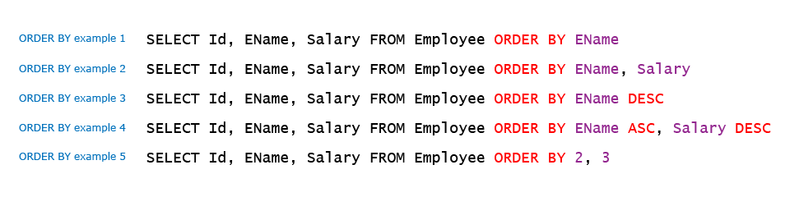
> select id,name,salry from employee 1 // sort basic on first column specified in select . in this we can sort only basic of those column which are specified in select.

NOTE - NULL is treated as highest value.

Note-Order By cannot be used on columns on which Grouping is not being done.
>SELECT Dept, SUM(Salary) FROM Employee GROUP BY Dept ORDER BY Designation
ORA-00979: not a GROUP BY expression

Group By
We know that aggregate functions are being used to calculate min, max, avg etc. for all records of the query. What if the requirement is to calculate subtotals at Department level? In that case, we will have to run the query once for every department. Is there a better way to achieve this functionality?
We can use GROUP BY to achieve such results using a single query. GROUP BY groups the data from the table into different groups based on the criteria provided and calculates the aggregate function for each group. Thus the result has 1 row for each group.
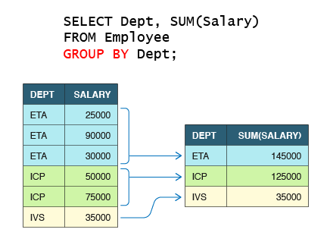
Group By converts the entire rows in a group into a single row in result. You cannot fetch details from individual rows in a category. Let us try to fetch count and names of employees in each department.
>SELECT Dept, ENAME, Count(ID) FROM Employee GROUP BY Dept;
ORA-00979: not a GROUP BY expression
The query fails as Group By is done on Dept and Name is at a row level within a dept.

Group By can also be used with multiple columns. In that case it treats each distinct combination of the columns as a single category. Let us display maximum salary paid to each designation, within each department.
>SELECT Dept, Designation, MAX(Salary) FROM Employee GROUP BY Dept, Designation;
DEPT | DESIGNATION | MAX(SALARY)
ETA | SE | 25000
ETA | SSE | 30000
ICP | PM | 75000
ICP | TA | 40000
ETA | PM | 90000

You can nest aggregate functions up to maximum of 2 levels using Group By clause.
>SELECT MAX(AVG(Salary)) FROM Employee GROUP BY dept;
MAX(AVG(SALARY))
57500

You can use GROUP BY with columns that contain NULL values.
>SELECT Bonus, Count(*) FROM Employee GROUP BY Bonus
BONUS | COUNT(*)
1000 | 1
NULL | 2
1200 | 1
100 | 1

>SELECT Dept, AVG(Salary) AvgSal FROM Employee GROUP BY 1 ORDER BY 2 DESC // this will be executed succesfully.

Having Clause
We saw how to use GROUP BY in conjunction with aggregate functions to get summary of data category wise. What if we want to filter this summary? For e.g. if we want to fetch only those departments whose average salary of their employees is greater than a specific value.
This can be achieved using HAVING clause. Having allows aggregate functions to be used as filter criteria which cannot be done using WHERE clause

Union and Union All

The SQL UNION Operator
The UNION operator is used to combine the result-set of two or more queries.

Note: If some customers or suppliers have the same city, each city will only be listed once, because UNION selects only distinct values. Use UNION ALL to also select duplicate values!

SQL UNION ALL Example
The following SQL statement returns the cities (duplicate values also) from both the "Customers" and the "Suppliers" table:
SELECT City FROM Customers
UNION ALL
SELECT City FROM Suppliers
ORDER BY City;

Union with where clause
SELECT City, Country FROM Customers
WHERE Country='Germany'
UNION
SELECT City, Country FROM Suppliers
WHERE Country='Germany'
ORDER BY City;

Order in union
窗体顶端
UNION clause does not guarantee the order in which rows from both SELECT statements will appear in the final result. You can use ORDER BY to sort the final result. ORDER BY clause and limit clause can be placed only once and it must be at the end of second SELECT statement. And this applied to final result set.

>SELECT CompId FROM Employee UNION SELECT CompId FROM Computer ORDER BY CompId
So if we want to use order by and limit on individual query then we need to cover our queries in paranthesis.
- (select * from t1 order by city limit 1)
Union
(select * from t2 order by city limit 2);

窗体底端

Joins in Mysql
How to fetch data from multiple tables in a single query? Let us say we have a requirement to display employee id, employee name along with computer id, model of the computer allocated to the employee in a single tabular format. The input tables and sample output is provided below:
These requirements can be met using JOINS which can combine data from multiple tables. JOINs are of multiple types:
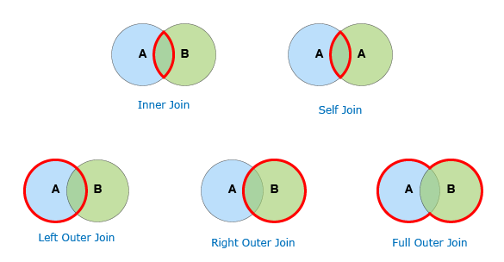
In addition, we also have Cross Join also called Cartesian product which is of academic interest only and is rarely used.

Cross Join
CROSS Join is also referred to as Cartesian Product. A CROSS join with m rows in table A and n rows in table B will always produce m * n rows. Essentially it combines each row from the first table with each row of the second table. A cross join is rarely used as it mostly produces lot of meaningless data. However it is useful to understand the concept of other joins. Let us understand this join using Employee and Computer tables.
>SELECT E.ID, E.ENAME, E.COMPID AS E_COMPID, C.COMPID, C.Model
FROM Employee E CROSS JOIN Computer C

INNER JOIN
INNER Join is the most frequently used JOIN. It matches the records from both tables based on the join predicate and returns only the matched rows. For ease of understanding one can think that first a Cartesian Product is created and then all the rows that do not meet the join condition are dropped from the result. Inner join also has a short hand syntax given its wide use. Let us understand this join using tables in Employee database:
SELECT ID, ENAME, E.COMPID AS E_COMPID, C.COMPID AS C_COMPID, MODEL
FROM Employee E INNER JOIN Computer C ON E.COMPID = C.COMPID

ID | ENAME | E_COMPID | C_COMPID | MODEL
1 | James Potter | 1001 | 1001 | Vostro
3 | Emily Rayner | 1002 | 1002 | Precision
5 | Ayaz Mohammad | 1003 | 1003 | Edge

Inner join with conditions
While using Inner Joins we might have requirements to filter rows based on some condition e.g. a need to fetch all employees from ETA who are allocated a computer. The filter condition can be supplied in two ways when using ANSI syntax ( t1 INNER JOIN t2 ON condition).
Option 1: Using a WHERE clause
The query is evaluated using a two-step process:
Step 1. Two tables are joined using join condition and resultset is evaluated
Step 2. Filter condition in WHERE clause is applied on all the rows of the resultset to give the final result
Option 2: Combining with the join condition using AND operator

Here the query is evaluated in a single step as the filter condition is applied right at the time of join condition evaluation.
Note:-Both these query versions give identical results for INNER joins.

Joining multiple tables
>select s_name, score, status, address_city, email_id,
accomplishments from student s inner join marks m on
s.s_id = m.s_id inner join details d on
d.school_id = m.school_id;

Firstly two tables are combined ,then resultant table combined with third table.

Self Join
SELF Join represents join of a table with itself. In this example we use inner self join to retrive employee's manager name. The Cartesian product of Employee table with itself will contain 5 x 5 = 25 rows. However only three rows have manager matching id and these appears on the result.
Employee Table
ID | ENAME | DOJ | SALARY | BONUS | DEPT | DESIGNATION | MANAGER
1 | James Potter | 01-Jun-14 | 75000 | 1000 | ICP | PM | NULL
2 | Ethan McCarty | 01-Feb-14 | 90000 | 1200 | ETA | PM | NULL
3 | Emily Rayner | 01-Jan-14 | 25000 | 100 | ETA | SE | 2
4 | Jack Abraham | 01-Jul-14 | 30000 | NULL | ETA | SSE | 2
5 | Ayaz Mohammad | 01-Apr-14 | 40000 | NULL | ICP | TA | 1

>SELECT EMP.ID EMPID, EMP.ENAME EMPNAME, MGR.ID MGRID, MGR.ENAME MGRNAME
FROM Employee EMP INNER JOIN Employee MGR ON EMP.MANAGER = MGR.ID
EMPID | EMPNAME | MGRID | MGRNAME
5 | Ayaz Mohammad | 1 | James Potter
3 | Emily Rayner | 2 | Ethan McCarty
4 | Jack Abraham | 2 | Ethan McCarty
Q)Given the Employee table as input, choose the query that produces the output below?
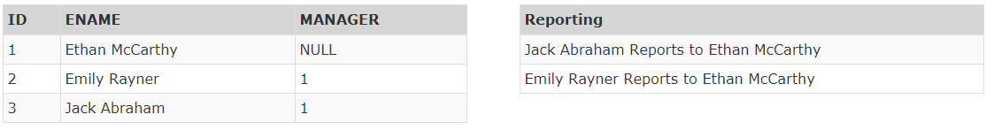
Ans - >select concat(E1.empname,” Reports to “, E2.empname) Reporting from Employee E1 inner join Employee E2 on E1.manager = E2.id;

Left-outer Join
LEFT OUTER Join for tables A and B will always return all records from table A even if matching record is not found in table B as per the join condition. For records where match is found the result set is exactly same as the inner join result. However for non matching records all columns from table B appear as NULL in the result. Let us understand this join using Employee and Computer tables:
>SELECT ID, ENAME, E.COMPID AS E_COMPID, C.COMPID AS C_COMPID, MODEL FROM Employee E LEFT OUTER JOIN Computer C ON E.COMPID = C.COMPID
Left Outer Join is used to fetch all rows from a main table and some additional information from a lookup table using join condition. Unlike INNER JOINs additional conditions have to be supplied carefully depending upon the business requirement.
If the objective is to filter all records from the resultset then the filter condition must be supplied through the WHERE clause, e.g. a need to show employee details and model of their allocated computer for all employees who belong to 'ETA'.
However care must be taken that this filter condition is using an attribute from the main table. Any attempt to filter (except check for NULL) using attribute from lookup table will result in wrong output as all NULL rows will get filtered and the purpose of using OUTER join will get defeated.
If we want to conditionally fetch values from the lookup table then the additional criteria must be combined with the join condition using AND operator, e.g. a need to show details of all employees and in addition model of allocated computer for only those employees who are allocated a computer manufactured in '2014'.

Right outer Join
RIGHT OUTER Join for tables A and B will always return all records from table B even if matching record is not found in table A as per the join condition. Right outer join is the mirror image of left join. In fact it is rarely used because the same resultset can be obtained by using a left join and reversing the order of the tables in the query.
>SELECT ID, ENAME, E.COMPID AS E_COMPID, C.COMPID AS C_COMPID, MODEL
FROM Employee E RIGHT OUTER JOIN Computer C ON E.COMPID = C.COMPID

Full Outer Join
FULL OUTER Join combines the effect of both LEFT OUTER JOIN and the RIGHT OUTER JOIN. Full Outer Join between table A and table B returns matched as well as unmatched rows from both tables. For two tables with p and q rows, a 1:1 relationship and m matched rows the total number of rows in the resultset is m + (p - m) + (q - m) = p + q - m.
>SELECT ID, ENAME, E.COMPID AS E_COMPID, C.COMPID AS C_COMPID, MODEL
FROM Employee E FULL OUTER JOIN Computer C ON E.COMPID = C.COMPID

Note - Mysql do not have full outer join,for full outer join in mysql
SELECT * FROM t1LEFT JOIN t2 ON t1.id = t2.id
UNION
SELECT * FROM t1RIGHT JOIN t2 ON t1.id = t2.id

Modular query writing
Problem
Display ToyId, ToyName, Stock of those toys whose stock lies within 10 and 15(both inclusive) and toyname contains more than 6 characters.
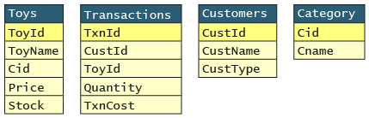
Columns | Tables | Display | Row Filter | Join | Aggregate | Group | Group Filter | Subquery | Misc.
ToyId | Toys | Yes
ToyName | Toys | Yes | Yes |  |  |  |  |  | LENGTH()
Stock | Toys | Yes | Yes
Query Design is now complete. We'll now write the query in incremental steps.

Views in Mysql
Views in SQL are kind of virtual tables. A view also has rows and columns as they are in a real table in the database. We can create a view by selecting fields from one or more tables present in the database. A View can either have all the rows of a table or specific rows based on certain condition. In this article we will learn about creating , deleting and updating Views.
Views do not occupy any space

- Creating View from a single table:
  - In this example we will create a View named DetailsView from the table StudentDetails. Query:
>CREATE VIEW DetailsView AS
SELECT NAME, ADDRESS
FROM StudentDetails
WHERE S_ID < 5;
- Creating View from multiple tables: In this example we will create a View named MarksView from two tables StudentDetails and StudentMarks. To create a View from multiple tables we can simply include multiple tables in the SELECT statement. Query:
>CREATE VIEW MarksView AS
SELECT StudentDetails.NAME, StudentDetails.ADDRESS, StudentMarks.MARKS
FROM StudentDetails, StudentMarks
WHERE StudentDetails.NAME = StudentMarks.NAME;

DELETING VIEWS
>DROP VIEW view_name;

UPDATING VIEWS

There are certain conditions needed to be satisfied to update a view. If any one of these conditions is not met, then we will not be allowed to update the view.
- The SELECT statement which is used to create the view should not include GROUP BY clause or ORDER BY clause.
- The SELECT statement should not have the DISTINCT keyword.

- The view should not be created using nested queries or complex queries.
- The view should be created from a single table. If the view is created using multiple tables then we will not be allowed to update the view.
We can use the CREATE OR REPLACE VIEW statement to add or remove fields from a view. We can’t use alter on views.

Inserting a row in a view:
- We can insert a row in a View in a same way as we do in a table. We can use the INSERT INTO statement of SQL to insert a row in a View.Syntax:
INSERT INTO view_name(column1, column2 , column3,..)
VALUES(value1, value2, value3..);
It will be updated in main table,but we don’t need to provide values for other columns of original table,it will automatically insert null if there is no constraint on original table which restrict inserting null.

Deleting a row from a View:
- Deleting rows from a view is also as simple as deleting rows from a table. We can use the DELETE statement of SQL to delete rows from a view. Also deleting a row from a view first delete the row from the actual table and the change is then reflected in the view.Syntax:
>DELETE FROM view_name
WHERE condition;

WITH CHECK OPTION
The WITH CHECK OPTION clause in SQL is a very useful clause for views. It is applicable to a updatable view. If the view is not updatable, then there is no meaning of including this clause in the CREATE VIEW statement.
- The WITH CHECK OPTION clause is used to prevent the insertion of rows in the view where the condition in the WHERE clause in CREATE VIEW statement is not satisfied.
- If we have used the WITH CHECK OPTION clause in the CREATE VIEW statement, and if the UPDATE or INSERT clause does not satisfy the conditions then they will return an error.
Example: In the below example we are creating a View SampleView from StudentDetails Table with WITH CHECK OPTION clause.

>CREATE VIEW SampleView AS
SELECT S_ID, NAME
FROM StudentDetails
WHERE NAME IS NOT NULL
WITH CHECK OPTION;
In this View if we now try to insert a new row with null value in the NAME column then it will give an error because the view is created with the condition for NAME column as NOT NULL. For example,though the View is updatable but then also the below query for this View is not valid:

Sub Query
Subquery is a query inside a query. A subquery should be enclosed in parenthesis and can be used in SELECT, FROM, WHERE and HAVING clauses.

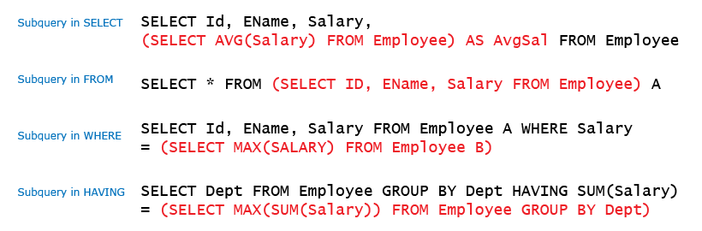

In Select cluase we can use only scaler subquery.scaler subquery are the one which return only one row and one column.

Output from subquery in ‘from clause’ is known as inline view.inline view can return multiple rows and multiple columns.

A Query in where clause is refered as nested subquery.
Subquery in SELECT and FROM clause are not used often. Subqueries in WHERE and HAVING clauses are classified into the following:-
1. Independent subquery
2. Correlated subquery

Independent Sub Query
In an independent subquery, the inner queries and outer queries are independent of each other. You can run an inner query and inspect its result independent of the outer query. Independent subquery is further classified into
single row
multiple row
types depending upon the number of rows returned.
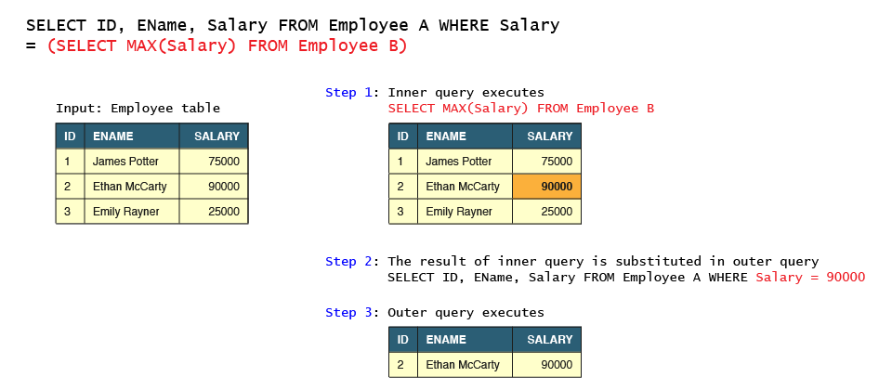
>SELECT Id, EName, Salary, Dept FROM Employee E1 WHERE Salary = (SELECT MAX(Salary) FROM Employee E2)

- Display the department in which the maximum total salary is paid to the employees.
>SELECT DEPT FROM Employee GROUP BY DEPT HAVING SUM(Salary) = (SELECT MAX(SUM(Salary)) FROM Employee GROUP BY Dept);
Display the details of computer which are allocated to the employees.
>SELECT CompId, Make, Model FROM Computer WHERE CompId IN (SELECT CompId FROM Employee);

Independent subquery can be replaced by join if it is used with IN clause to fetch foreign keys from another table. The JOIN solution for query in example 3 (Multiple Row- In Operator) is:
>SELECT C.CompId, Make, Model FROM Computer C, Employee E WHERE E.CompId = C.CompId;
A Join cannot be replaced by a subquery if it is using columns from both the tables in SELECT clause. Attributes from subquery tables cannot be accessed in the outer query.

A Subquery must be used if value of aggregate function is required in where clause.
>SELECT EName,Dept FROM Employee WHERE Salary>(SELECT AVG(Salary) FROM Employee);

Corelated Sub Query
A Correlated subquery is the type of query in which the inner query depends upon the outer query for its execution. Specifically, the inner query uses an attribute from one of the tables in the outer query. The inner query is executed iteratively for each selected record of the outer query. In the case of independent subquery, the inner query just executes once.
Below is a correlated subquery is written, to fetch the details of the employee(s) who are earning salary more than or same as the average salary earned by employees of the same designation.
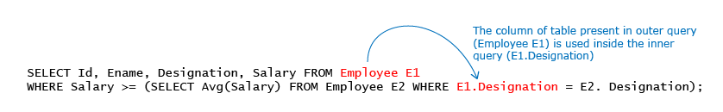

Exist Keyword
EXISTS keyword is used to check presence of rows in the subquery. The main query returns the row only if at least one row exists in the subquery. EXISTS clause follows short circuit logic i.e. the query calculation is terminated as soon as criteria is met. As a result it is generally faster than equivalent join statements.
SELECT CompId, Make, Model FROM Computer C WHERE EXISTS (SELECT 1 FROM Employee E WHERE E.CompId = C.CompId);
- Display the names of salesmen who have made at least 1 sale in the month of Jun 2015.
Salesman (Sid, Sname, Location)
Product (Prodid, Pdesc, Price, Category, Discount)
Sale (Saleid, Sid, Sldate, Amount)
Saledetail (Saleid, Prodid, Quantity)
Ans ->select sname from salesman s1 where exists(select s3.sid from sale s3 where s1.sid = s3.sid and to_char(sldate,'MM/YY') = '06/15');

Window functions
A window function performs an aggregate-like operation on a set of query rows. However, whereas an aggregate operation groups query rows into a single result row, a window function produces a result for each query row:

- The row for which function evaluation occurs is called the current row.
- The query rows related to the current row over which function evaluation occurs comprise the window for the current row.
By contrast, window operations do not collapse groups of query rows to a single output row. Instead, they produce a result for each row. Like the preceding queries, the following query uses SUM(), but this time as a window function:
window_function_name(expression) OVER ( [partition_defintion] [order_definition] [frame_definition] )
In this syntax:
- First, specify the window function name followed by an expression.
- Second, specify the OVER clause which has three possible elements: partition definition, order definition, and frame definition.

mysql> SELECT
year, country, product, profit,
SUM(profit) OVER() AS total_profit,
SUM(profit) OVER(PARTITION BY country) AS country_profit
FROM sales
ORDER BY country, year, product, profit;+------+---------+------------+--------+--------------+----------------+| year | country | product | profit | total_profit | country_profit |+------+---------+------------+--------+--------------+----------------+| 2000 | Finland | Computer | 1500 | 7535 | 1610 || 2000 | Finland | Phone | 100 | 7535 | 1610 || 2001 | Finland | Phone | 10 | 7535 | 1610 || 2000 | India | Calculator | 75 | 7535 | 1350 || 2000 | India | Calculator | 75 | 7535 | 1350 || 2000 | India | Computer | 1200 | 7535 | 1350 || 2000 | USA | Calculator | 75 | 7535 | 4575 || 2000 | USA | Computer | 1500 | 7535 | 4575 || 2001 | USA | Calculator | 50 | 7535 | 4575 || 2001 | USA | Computer | 1200 | 7535 | 4575 || 2001 | USA | Computer | 1500 | 7535 | 4575 || 2001 | USA | TV | 100 | 7535 | 4575 || 2001 | USA | TV | 150 | 7535 | 4575 |+------+---------+------------+--------+--------------+----------------+
Each window operation in the query is signified by inclusion of an OVER clause that specifies how to partition query rows into groups for processing by the window function:

- The first OVER clause is empty, which treats the entire set of query rows as a single partition. The window function thus produces a global sum, but does so for each row.

- The second OVER clause partitions rows by country, producing a sum per partition (per country). The function produces this sum for each partition row.

Window functions are permitted only in the select list and ORDER BY clause. Query result rows are determined from the FROM clause, after WHERE, GROUP BY, and HAVING processing, and windowing execution occurs before ORDER BY, LIMIT, and SELECT DISTINCT.
The OVER clause is permitted for many aggregate functions, which therefore can be used as window or nonwindow functions, depending on whether the OVER clause is present or absent:
AVG()
BIT_AND()
BIT_OR()
BIT_XOR()
COUNT()
JSON_ARRAYAGG()
JSON_OBJECTAGG()
MAX() MIN()
STDDEV_POP(),
STDDEV(),
STD()
STDDEV_SAMP()
SUM()
VAR_POP(),
VARIANCE()
VAR_SAMP()
MySQL also supports nonaggregate functions that are used only as window functions. For these, the OVER clause is mandatory:

CUME_DIST()
DENSE_RANK()
FIRST_VALUE()
LAG()
LAST_VALUE()
LEAD()
NTH_VALUE()
NTILE()
PERCENT_RANK()
RANK()
ROW_NUMBER()

Over() Clause
As mentioned previously, to use a window function (or treat an aggregate function as a window function), include an OVER clause following the function call. The OVER clause has two forms:

over_clause:
{OVER (window_spec) | OVER window_name}
Both forms define how the window function should process query rows. They differ in whether the window is defined directly in the OVER clause, or supplied by a reference to a named window defined elsewhere in the query:

- In the first case, the window specification appears directly in the OVER clause, between the parentheses.

- In the second case, window_name is the name for a window specification defined by a WINDOW clause elsewhere in the query. For details, see Section 12.21.4, “Named Windows”.

For OVER (window_spec) syntax, the window specification has several parts, all optional:
window_spec:
[window_name] [partition_clause] [order_clause] [frame_clause]

OVER ( [ <PARTITION BY clause> ] [ <ORDER BY clause> ] [ <ROW or RANGE clause> ] )

If OVER() is empty, the window consists of all query rows and the window function computes a result using all rows. Otherwise, the clauses present within the parentheses determine which query rows are used to compute the function result and how they are partitioned and ordered:
mysql> SELECT year, country, product, profit, ROW_NUMBER() OVER(PARTITION BY country) AS row_num1, ROW_NUMBER() OVER(PARTITION BY country ORDER BY year, product) AS row_num2 FROM sales;

Named Windows
Windows can be defined and given names by which to refer to them in OVER clauses. To do this, use a WINDOW clause. If present in a query, the WINDOW clause falls between the positions of the HAVING and ORDER BY clauses, and has this syntax:
SELECT val, ROW_NUMBER() OVER w AS 'row_number', RANK() OVER w AS 'rank', DENSE_RANK() OVER w AS 'dense_rank' FROM numbers WINDOW w AS (ORDER BY val);
SELECT DISTINCT year, country, FIRST_VALUE(year) OVER (w ORDER BY year ASC) AS first, FIRST_VALUE(year) OVER (w ORDER BY year DESC) AS last FROM sales WINDOW w AS (PARTITION BY country);

- Aggregate Window Functions: These functions operated on multiple rows and Examples of such functions are SUM(), MAX(), MIN(), AVG(), COUNT(), etc.
- Ranking Window Functions: These functions ranks each row of a partition in a table. Example of such functions are RANK(), DENSE_RANK(), ROW_NUMBER() etc.
- Analytical functions: These functions are locally represented by a power series. Example of such functions are NTILE(),LAG(), LEAD(), FIRST_VALUE(), LAST_VALUE(), etc.

Row_number Window Funciton
The ROW_NUMBER() is a window function that assigns a sequential integer to each row of a query’s result set. Rows are ordered starting from one based on the order specified by the ORDER BY clause in the window definition.
The following shows the syntax of the ROW_NUMBER() function:
ROW_NUMBER() OVER (
[PARTITION BY expression1, expression2,...]
ORDER BY expression1 [ASC | DESC], expression2,...
)
Code language: SQL (Structured Query Language) (sql)
In this syntax,
- First, the PARTITION BY clause divides the rows derived from the FROM clause into partitions. The PARTITION BY clause is optional. If you skip it, the ROW_NUMBER() will treat the whole result set as a single partition.
- Then, the ORDER BY clause specifies the order of the rows in each partition. The ORDER BY clause is mandatory because the ROW_NUMBER() function is order sensitive.
- Finally, each row in each partition is assigned a sequential integer number called row number. The row number is reset for each partition.
SELECT ROW_NUMBER () OVER ( PARTITION BY Country ORDER BY FirstName ) RowNum, FirstName, LastName, country FROM customers;
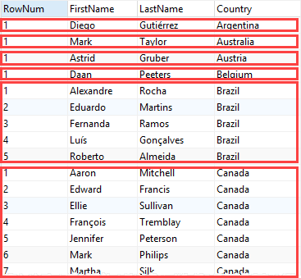

Rank() Window Function
Rank is same as Row_number but for duplicates it assigns the same rank,but it also skips some number

For eg.
Sal rank
200 1
200 1
300 3

Dense_rank() window Function
It is same as rank function but do not skip any ranking.
If there are no duplicates in our data then row_number,rank(),dense_rank() will give the same result.

Lag() and Lead()
The LAG() function is used to get value from row that precedes the current row.
The LEAD() function is used to get value from row that succeeds the current row.

What if we want previous rows or next rows column values in current row,in than scenario we use lag and lead.
Syntax:
For LEAD() function-
LEAD(expr, N, default)
OVER (Window_specification | Window_name)
For LAG() function-
LAG(expr, N, default)
OVER (Window_specification | Window_name)
The N and default argument in the function is optional.
Parameters used:
- expr: It can be a column or any bulit-in function.
- N: It is a positive value which determine number of rows preceding/succeeding the current row. If it is omitted in query then its default value is 1.
- default: It is the default value return by function in-case no row precedes/succeedes the current row by N rows. If it is missing then it is by default NULL.
- OVER(): It defines how rows are partitioned into groups. If OVER() is empty then function compute result using all rows.
- Window_specification: It consist of query partition clause which determines how the query rows are partitioned and ordered.
- Window_name: If window is specified elsewhere in the query then it is referenced using this Window_name.

Frame clause
The default window frame without the ORDER BY is the whole partition. But when you use the ORDER BY, the default window frame is RANGE BETWEEN UNBOUNDED PRECEDING AND CURRENT ROW
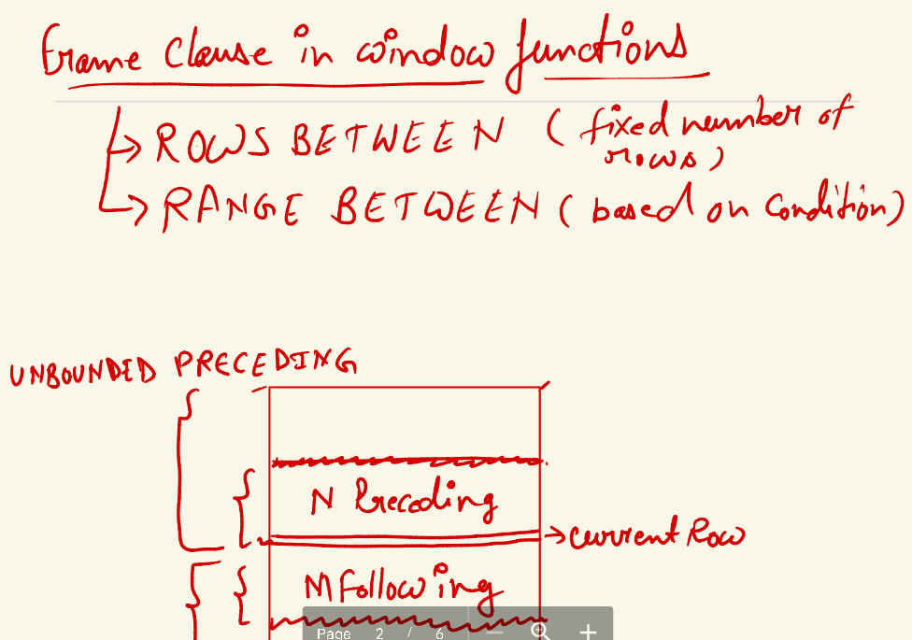

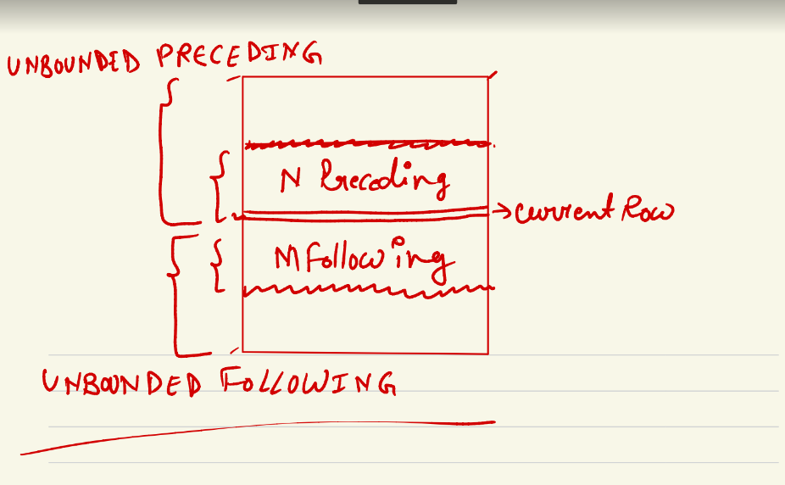
Note - we need to give both direction upward and downward otherwise compiler generates error,so for going in one direction we use current row for another direction.

select *,
sum(sales_amount) over(order by sales_date rows between 1 preceding and 1 following) as prev_plus_next_sales_sum
from daily_sales;
select *,
sum(sales_amount) over(order by sales_date rows between 1 preceding and current row) as prev_plus_next_sales_sum
from daily_sales; // only in one direction
select *,
sum(sales_amount) over(order by sales_date rows between current row and 1 following) as prev_plus_next_sales_sum
from daily_sales;

Notes - order by is optional in rows between,but compulsory in range between

# How to work with Range Between

select *,
sum(sales_amount) over(order by sales_amount range between 100 preceding and 200 following) as prev_plus_next_sales_sum
from daily_sales; // order by required in range between and range is applied on the same column and only one column in allowed in order by.
# Calculate the running sum for a week
# Calculate the running sum for a month
insert into daily_sales values('2022-03-20',900);
insert into daily_sales values('2022-03-23',200);
insert into daily_sales values('2022-03-25',300);
insert into daily_sales values('2022-03-29',250);
select * from daily_sales;
select *,
sum(sales_amount) over(order by sales_date range between interval '6' day preceding and current row) as running_weekly_sum
from daily_sales; // interval is for working with date

You can’t use window functions in WHERE, because the logical order of operations in an SQL query is completely different from the SQL syntax. The logical order of operations in SQL is:
- FROM, JOIN
- WHERE
- GROUP BY
- aggregate functions
- HAVING
- window functions
- SELECT
- DISTINCT
- UNION/INTERSECT/EXCEPT
- ORDER BY
- OFFSET
- LIMIT/FETCH/TOP
This means that the filters in a WHERE clause are processed before window functions. At the time the WHERE clause is processed, the window functions would not have been computed yet. And if they are not yet computed, you can’t refer to them in WHERE.
This order of operations implies that you can only use window functions in SELECT and ORDER BY. That is, window functions are not accessible in WHERE, GROUP BY, or HAVING clauses. For this reason, you cannot use any of these functions in WHERE: ROW_NUMBER(), RANK(), DENSE_RANK(), LEAD(), LAG(), or NTILE()

Load data into table
MySQL LOAD statement populates a table.
Suppose the user have a .txt file name 'pub.txt' in a folder of its own, containing 1 record per line and separated by tabs and arranged in order as the columns listed in the table. You can use LOAD statement to populate the table. For missing values, the user can use NULL values and that should be represented by ‘\N’ in the text file.
LOAD DATA LOCAL INFILE '[path/][file_name]' INTO TABLE [table_name ];

>LOAD DATA LOCAL INFILE 'path/pub.txt' INTO TABLE publisher
LINES TERMINATED BY \r\n ;
MySQL import data from csv using LOAD DATA INFILE
You can import data from a CSV file into a MySQL table. Here are the MySQL table structure and the CSV
MySQL> LOAD DATA LOCAL INFILE 'book1.csv' INTO table std
FIELDS TERMINATED BY ','
ENCLOSED BY '"'
LINES TERMINATED BY '\r\n'
IGNORE 1 LINES (name, class, rollno);
Query OK, 4 rows affected (0.04 sec)
Records: 4 Deleted: 0 Skipped: 0 Warnings: 0
MySQL> SELECT * FROM std;
+--------+-------+--------+
| rollno | class | name |
+--------+-------+--------+
| 9 | V | David |
| 10 | VI | Taniya |
| 12 | Vii | Subir |
| 14 | V | Anish |
+--------+-------+--------+
4 rows in set (0.00 sec)

Another simplest way is to use workbench to load data

Partitioning in mysql

Need for Partitioning:
Consider the BOOKING table containing millions of records. Querying such tables is time consuming and may lead to performance bottle neck as well. So partitions are used for improving performance while querying tables with huge data.
In partitioning, table data is evenly distributed into different parts based on some logic. So when we query for particular table data, only a particular partition will be searched instead of searching the entire table. This can be done using the PARTITION option of CREATE TABLE command.

Partition types:
- RANGE
- LIST
- HASH
- KEY

RANGE:
In this type, user should explicitly specify the range of values based on which records get stored in each partition.
Example:
The below query creates a BOOKING table with four partitions R0, R1, R2 and R3. Partition R0 contains records with YEAR(BOOKING_CHECKIN) before 2015, R1 contains bookings between 2015 and 2016, R2 contains bookings between 2016 and 2017 and MAXVALUE in partition R3 denotes all the bookings made after 2017.
- DROP TABLE IF EXISTS BOOKING;
- CREATE TABLE BOOKING (
BOOKING_ID int(11),
- BOOKING_ROOM_ID int(11),
- BOOKING_USER_EMAIL varchar(50
- BOOKING_CHECKOUT date,
- BOOKING_ROOM_RATING int(11),
- BOOKING_ROOM__PCOMMENTS varchar(250),
- BOOKING_ROOM__NCOMMENTS varchar(250)) ENGINE=InnoDB CHARSET=latin1
- PARTITION BY RANGE(YEAR(BOOKING_CHECKIN))
- ( PARTITION R0 VALUES LESS THAN (2015),
- PARTITION R1 VALUES LESS THAN (2016),
- PARTITION R2 VALUES LESS THAN (2017),PARTITION R3 VALUES LESS THAN MAXVALUE);

LIST:
It is similar to RANGE partitioning, but instead of specifying the range, we specify the set of values based on which records are added to each partition.

Example:
The below query creates two partitions L0 and L1. Partition L0 contains bookings for the years 2014 and 2015, while L1 contains bookings for years 2016 and 2017.
Note: The record will not get inserted into the table, if the partitioned column value is not specified in any of the list.
- DROP TABLE IF EXISTS BOOKING;

- CREATE TABLE BOOKING (
- BOOKING_ID int(11),
- BOOKING_ROOM_ID int(11),
- BOOKING_USER_EMAIL varchar(50),
- BOOKING_CHECKIN date,
- BOOKING_CHECKOUT date,
- BOOKING_ROOM_PRICE int(11),
- BOOKING_ROOM_RATING int(11),
- BOOKING_ROOM__PCOMMENTS varchar(250),
- BOOKING_ROOM__NCOMMENTS varchar(250)) ENGINE=InnoDB CHARSET=latin1
- PARTITION BY LIST(YEAR(BOOKING_CHECKIN))
- (PARTITION L0 VALUES IN (2014, 2015),
- PARTITION L1 VALUES IN (2016, 2017));

HASH
In RANGE and LIST partitioning, we explicitly specified values based on which records are stored in each partition. But in HASH partitioning, MySQL takes care of the partitioning logic based on the value of the partitioning column. The user only needs to specify the number of partitions required and the column to be considered for partitioning.
Example:
The below query creates four partitions and MySQL uses a hash function that is applied to YEAR(BOOKING_CHECKIN) column based on which rows will be added to any of the four partitions implicitly.
- DROP TABLE IF EXISTS BOOKING;

- CREATE TABLE BOOKING (
- BOOKING_ID int(11),
- BOOKING_ROOM_ID int(11),
- BOOKING_USER_EMAIL varchar(50),
- BOOKING_CHECKIN date,
- BOOKING_CHECKOUT date,
- BOOKING_ROOM_PRICE int(11),
- BOOKING_ROOM_RATING int(11),
- BOOKING_ROOM__PCOMMENTS varchar(250),
- BOOKING_ROOM__NCOMMENTS varchar(250)) ENGINE=InnoDB CHARSET=latin1
- PARTITION BY HASH (YEAR(BOOKING_CHECKIN))
- PARTITIONS 4;

KEY
It is similar to HASH partitioning, but here, the primary key is considered as the partitioning column by default. The user only needs to specify the number of partitions required.
Example:
The below query creates five partitions wherein MySQL uses the value of BOOKING_ID as input to the hash function to partition the data.
- DROP TABLE IF EXISTS BOOKING;

- CREATE TABLE BOOKING (
- BOOKING_ID int(11) PRIMARY KEY,
- BOOKING_ROOM_ID int(11),
- BOOKING_USER_EMAIL varchar(50),
- BOOKING_CHECKIN date,
- BOOKING_CHECKOUT date,
- BOOKING_ROOM_PRICE int(11),
- BOOKING_ROOM_RATING int(11),
- BOOKING_ROOM__PCOMMENTS varchar(250),
- BOOKING_ROOM__NCOMMENTS varchar(250)) ENGINE=InnoDB CHARSET=latin1
- PARTITION BY KEY()
- PARTITIONS 5;

Note: If a partition is no longer required, we can drop it using ALTER command which will be discussed later in this course

Index in mysql
MySQL uses indexes to quickly find rows with specific column values. Without an index, MySQL must scan the whole table to locate the relevant rows. The larger table, the slower it searches.
In this section, you will learn about MySQL index including creating indexes, removing indexes, listing all indexes of a table and other important features of indexes in MySQL.

MySQL CREATE INDEX statement
Typically, you create indexes for a table at the time of creation. For example, the following statement creates a new table with an index that consists of two columns c2 and c3.
CREATE TABLE t(
c1 INT PRIMARY KEY,
c2 INT NOT NULL,
c3 INT NOT NULL,
c4 VARCHAR(10),
INDEX (c2,c3)
);
Code language: SQL (Structured Query Language) (sql)
To add an index for a column or a set of columns, you use the CREATE INDEX statement as follows:
CREATE INDEX index_name ON table_name (column_list)
Code language: SQL (Structured Query Language) (sql)
To create an index for a column or a list of columns, you specify the index name, the table to which the index belongs, and the column list.
For example, to add a new index for the column c4, you use the following statement:
CREATE INDEX idx_c4 ON t(c4);

See indexes on table
To show the indexes of a table, you use the SHOW INDEXES statement, for example:
SHOW INDEXES FROM employees;

CTE(common table expression) or With clause
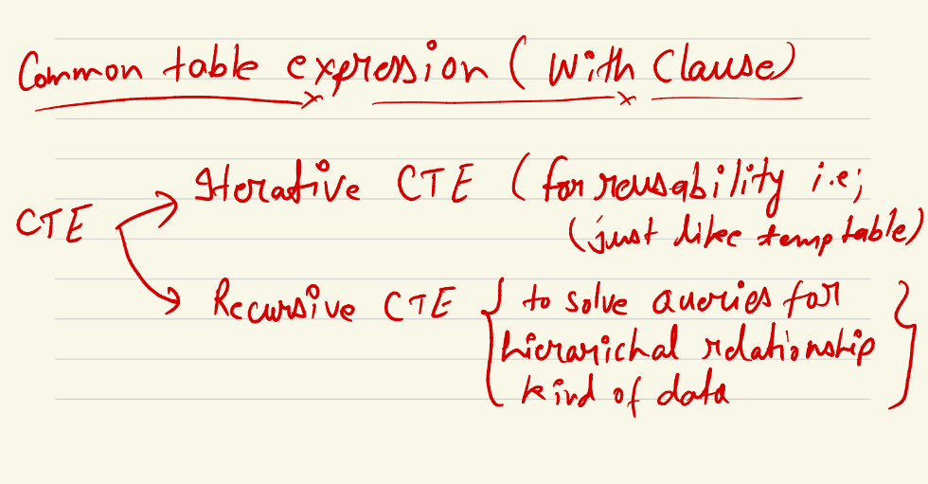

Iterative cte
--- Write a query to print the name of department along with the total salary paid in each department
--- Normal approach
select d.dept_name, tmp.total_salary
from (select dept_id , sum(salary) as total_salary from amazon_employees group by dept_id) tmp
inner join department d on tmp.dept_id = d.dept_id;
--- how to do it using with clause??
with dept_wise_salary as (select dept_id , sum(salary) as total_salary from amazon_employees group by dept_id)
select d.dept_name, tmp.total_salary
from dept_wise_salary tmp
inner join department d on tmp.dept_id = d.dept_id;

Recursive CTE

--- Write a Query to generate numbers from 1 to 10 in SQL
with recursive generate_numbers as
(
select 1 as n
union
select n+1 from generate_numbers where n<10
)
select * from generate_numbers;

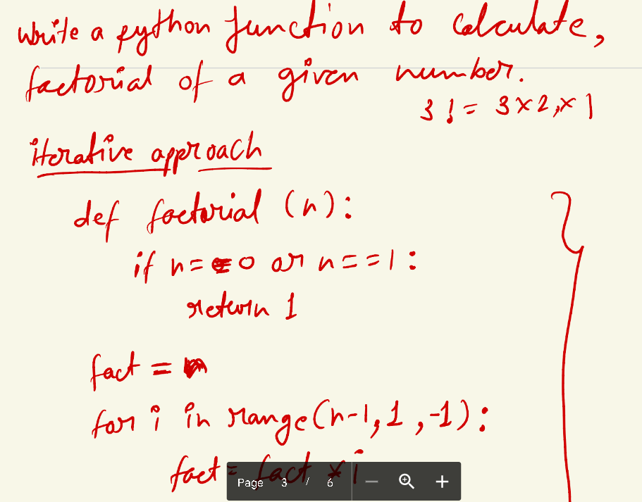
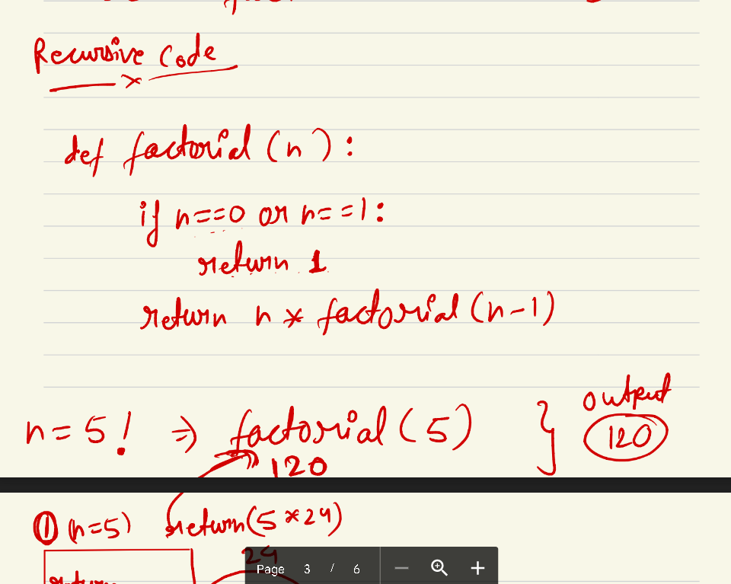

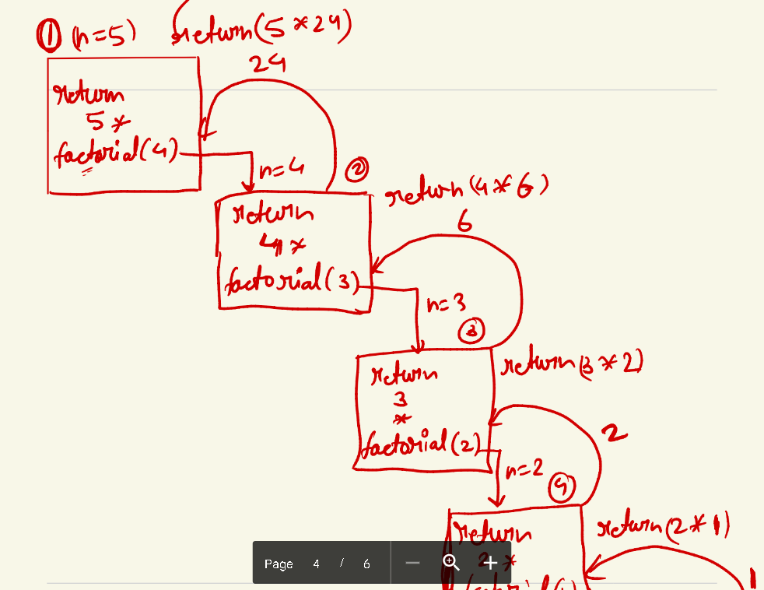

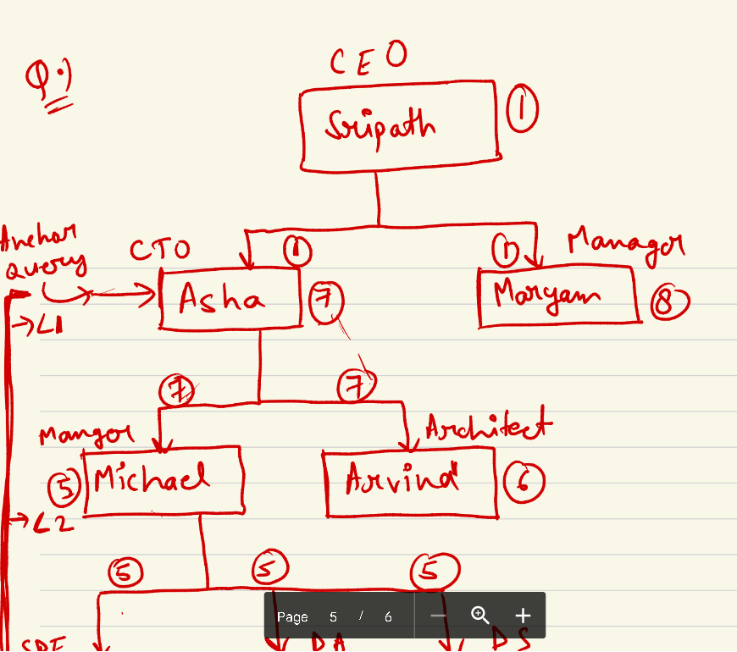

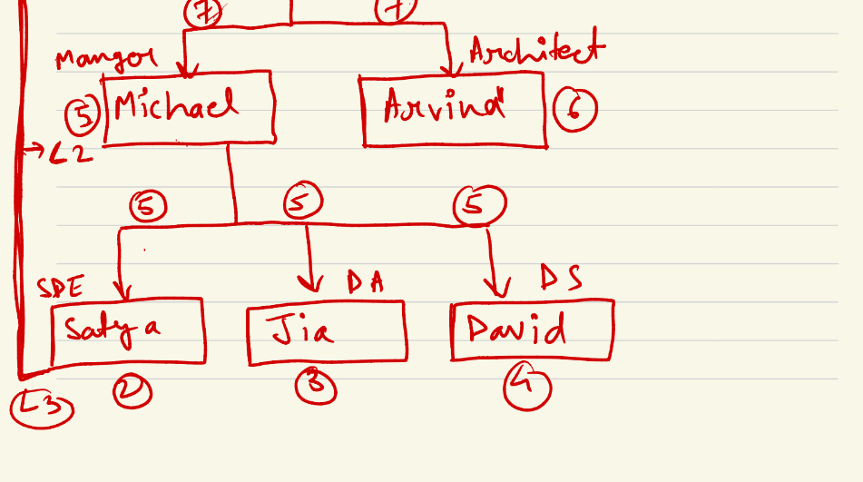

select * from emp_mgr;
--- for our CTO 'Asha', present her org chart
with recursive emp_hir as
(
select id, name, manager_id, designation from emp_mgr where name='Asha'
UNION
select em.id, em.name, em.manager_id, em.designation from emp_hir eh inner join emp_mgr em on eh.id = em.manager_id
)
select * from emp_hir;
--- Print level of employees as well
with recursive emp_hir as
(
select id, name, manager_id, designation, 1 as lvl from emp_mgr where name='Asha'
UNION
select em.id, em.name, em.manager_id, em.designation, eh.lvl + 1 as lvl from emp_hir eh inner join emp_mgr em on eh.id = em.manager_id
)
select * from emp_hir;

Compound Statements
The solution is to add procedural flavor to the non procedural ‘SQL’ language using MySQL 'Compound Statements'.
Compound statements have the following forms:

Stored procedures/functions: Used to group several SQL statements together and send them at one shot to the server for execution, which reduces the network traffic
Triggers: Ensures the data integrity and business integrity
Variables, Programming constructs, Cursors: Enable us to retrieve single/multiple records and keep them available for later processing

Declare and set
DECLARE:
DECLARE command can be used to declare any local variables as part of storage object like procedure, function etc.
- DECLARE <variablename> DATA_TYPE [ DEFAULT default_value ];
DEFAULT keyword is used to assign default value to the variable during declaration.
SET:
SET command can be used to assign value(s) to the variables.
- SET <variablename> = <newvalue>;
Let us see an example where both DECLARE and SET commands are used. Consider the function CALCULATE_ROOM_PRICE that we created in the previous example:
- DROP FUNCTION IF EXISTS CALCULATE_ROOM_PRICE;
- DELIMITER //
- CREATE FUNCTION CALCULATE_ROOM_PRICE(check_in DATE,check_out DATE,no_of_rooms INT,h_id INT,r_type VARCHAR(20))
- RETURNS FLOAT
- BEGIN
- DECLARE total_price FLOAT DEFAULT 0.0;
- DECLARE room_price_per_Day FLOAT;
- DECLARE days INT;
- SET room_price_per_day= 0.0;
- SET days=0;
- SELECT ABS(DATEDIFF(check_in,check_out)) INTO days;
- IF days=0 THEN
- RETURN -1;
- ELSE
- SELECT ROOM_PRICE INTO room_price_per_day FROM HOTEL_ROOM_DETAILS WHERE HOTEL_ID=h_id AND ROOM_TYPE=r_type;
- SET total_price=room_price_per_day*days*no_of_rooms;
- END IF;
- RETURN total_price;
- END;
- //
- DELIMITER ;
In the above example, local variables like total_price, room_price_per_day and days are declared and assigned with new values using DECLARE and SET command.
Note: All the variables required for the stored object should be declared immediately after BEGIN statement. If we try to add a DECLARE command in between the execution block the code will result in syntax error.

Stored Procedure

Purpose of a stored procedure

- If an action or series of actions is to be executed repeatedly then we can create it as a procedure and compile it for future execution. It will be stored in the database in compiled form, thus providing improved performance
- Data manipulation can be implemented in the business layer of the application, but integration with other systems becomes difficult with this approach. Instead, by using stored procedures, integration becomes much easier

Now, let us learn how to create a procedure and how to call it.
Syntax for creating procedure:
- CREATE PROCEDURE <proc_name> (<parameters with their modes>) /* Header */
- BEGIN
- <Statements> /* Body of procedure */
- END;
Below is the description for the syntax of stored procedures:
Header: It contains name of the procedure, parameters with their data type and mode
Body of the procedure: It contains set of statements enclosed with BEGIN … END. Statements can be any DDL, DML or TCL statements of MySQL or any other compound statements
Parameters: Each parameter in the procedure should contain mode of parameter, parameter name and datatype. Datatype can be any valid MySQL datatype
Modes of parameters: Parameter can have any one of the below three mode. If no modes are mentioned then the parameter mode will be IN by default
- IN mode parameters are used to pass the input values to the procedure when we call them
- OUT mode parameters are used to get the output values from the procedure
- INOUT mode parameters are used to pass input value to the procedure and get the value updated from the procedure

Syntax for calling a procedure:
- CALL <procedure_name>([param_value_1,param_value_2,.......]);
While calling a procedure, ensure that the INOUT mode parameter are initialized with proper input values before calling them.
Syntax to dropping a procedure:
- DROP PROCEDURE IF EXISTS <procedure_name>;
- DROP PROCEDURE IF EXISTS DELETE_BOOKING;
- DELIMITER //
- CREATE PROCEDURE DELETE_BOOKING(IN b_id INT)
- BEGIN
- DELETE FROM BOOKING where BOOKING_ID=b_id;
- SELECT "Booking deleted successfully" AS SUCCESS;
- END;
- //
- DELIMITER ;
Note: Since we execute sequence of commands, we need to change the DELIMITER from ; to any other special characters like // for example. This will make the interpreter to fetch all the commands we provide in the procedure and then execute them finally once we give //.
Once the above code is executed, procedure is created and it may be called several times. Here, procedure creation is compiling the procedure and storing it as a compiled object in database. In subsequent calls, the compiled procedure will be executed instead of compiling again thus improving performance.
- DROP PROCEDURE IF EXISTS FETCH_ROOM_PRICE;
- DELIMITER //
- CREATE PROCEDURE FETCH_ROOM_PRICE(IN r_id INT,OUT r_price INT)
- BEGIN
- SELECT ROOM_PRICE INTO r_price FROM HOTEL_ROOM_DETAILS WHERE ROOM_ID=r_id;
- END;
- //
- DELIMITER ;
The below CALL statement executes the above procedure and fetches the room price into OUT parameter 'result', which can be viewed using the SELECT command:
- CALL FETCH_ROOM_PRICE(1001,@result);
- SELECT @result;
Output of above SELECT command:
Note: @ before a variable name make the variable to have global scope
Note - only one select statement is allowed if it is returning something otherwise we can use any number of select if we are storing values in variable and we can use multiple out variable in single procedure .we can use insert,update,delete any number of times.

Step 1: Create the procedure using below code:
- DROP PROCEDURE IF EXISTS UPDATE_PROFILE;
- DELIMITER //
- CREATE PROCEDURE UPDATE_PROFILE(v_phone BIGINT(20), v_password VARCHAR(20), v_name VARCHAR(30), v_email VARCHAR(30), OUT success INT)
- BEGIN
- DECLARE v_out INT DEFAULT 0;
- DECLARE v_check_user INT DEFAULT 0;
- SELECT COUNT(*) INTO v_check_user FROM USER WHERE USER_EMAIL=v_email;
- IF v_check_user = 1 THEN
- UPDATE USER SET USER_PHONE=v_phone, USER_NAME=v_name, USER_PASSWORD=v_password WHERE USER_EMAIL=v_email;
- SET success=1;
- ELSE
- SET success=0;
- END IF;
- END;
- //
- DELIMITER ;

- CALL UPDATE_PROFILE(9988776655, 'Mark@123', 'Mark', 'mark.casperstay@gmail.com', @v_out);

Stored function
Stored functions are similar to stored procedures but it can returns only one value whenever it is called, unlike stored procedure, where we have to define explicit OUT parameters. So, If we need to compute a value repeatedly based on a logic, we can create it as a stored function. Similar to stored procedures, stored functions are also complied once and can be called many times. It accepts only IN mode parameters and should return a value.

Note we can return resultset from stored procedure but from function only one values is allowed.
Syntax for creating stored function:
- CREATE FUNCTION <function_name>([parameter1 datatype,parameter2 datatype,...])
- RETURNS return_datatype
- deterministic
- BEGIN
- <declaration_statements>;
- <executable_statements>;
- END;
A deterministic function always returns the same results if given the same input values. A nondeterministic function may return different results every time it is called, even when the same input values are provided.
Note: Executable statements in stored function can contain DDL and DML statements, but TCL statements are not supported.
Syntax for calling a function:
SELECT <function_name>([parameter1_value, parameter2_value, ...]);

- DROP FUNCTION IF EXISTS CALCULATE_ROOM_PRICE;
- DELIMITER //
- CREATE FUNCTION CALCULATE_ROOM_PRICE(check_in DATE,check_out DATE,no_of_rooms INT,h_id INT,r_type VARCHAR(20))
- RETURNS FLOAT
- BEGIN
- DECLARE total_price FLOAT;
- DECLARE room_price_per_Day FLOAT;
- DECLARE days INT;
- SET total_price= 0.0;
- SET room_price_per_day= 0.0;
- SET days=0;
- SELECT ABS(DATEDIFF(check_in,check_out)) INTO days;
- IF days=0 THEN
- RETURN -1;
- ELSE
- SELECT ROOM_PRICE INTO room_price_per_day FROM HOTEL_ROOM_DETAILS WHERE HOTEL_ID=h_id AND ROOM_TYPE=r_type;
- SET total_price=room_price_per_day*days*no_of_rooms;
- END IF;
- RETURN total_price;
- END;
- //
- DELIMITER ;
Observe the RETURNS clause in the header of this function, which tells the datatype of the return value and the RETURN command, which returns data from this function to the calling block.

To call the above function use the below command:
- SELECT FUNC_CALCULATE_RATE ('2017-08-07','2017-08-09',1,1,'Double Room AC');

IF-ELSE conditional construct:
- IF expression THEN
- statement
- [ELSEIF expression THEN
- statement]
- .
- .

- [ELSE
- statement]
- ENDIF;
Example:
Consider the following code which is used for updating the user profile. Here, we are checking the value of the variable v_check_user if it is set to 1 or 0 in order to know whether the USER_EMAIL exist in the USER table or not. Based on the outcome of this condition, IF block or ELSE block will get executed.
- DROP PROCEDURE IF EXISTS UPDATE_PROFILE;
- DELIMITER //
- CREATE PROCEDURE UPDATE_PROFILE(v_phone BIGINT(20), v_password VARCHAR(20), v_name VARCHAR(30), v_email VARCHAR(30), OUT success INT)
- BEGIN
- DECLARE v_out INT DEFAULT 0;
- DECLARE v_check_user INT DEFAULT 0;
- SELECT COUNT(*) INTO v_check_user FROM USER WHERE USER_EMAIL=v_email;
- IF v_check_user = 1 THEN
- UPDATE USER SET USER_PHONE=v_phone, USER_NAME=v_name, USER_PASSWORD=v_password WHERE USER_EMAIL=v_email;
- SET success=1;
- ELSE
- SET success=0;
- END IF;
- END;
- //
- DELIMITER ;

IF function vs IF statements
Pay attention that the IF function is not the same as the IF statement.
The IF function returns a value for a specified condition and has the following syntax:
IF(expr,if_true_expr,if_false_expr)
The function returns if_true_expr if expr evaluates to true (it is not NULL). Otherwise, it returns if_false_expr. Based on how it is used, the IF function returns either a numeric value or a string.

SELECT SUM(IF(status = 'Completed', 1, 0)) AS Completed FROM tasks;

Loops in mysql

Indefinite loop structure
In indefinite loops, end condition will not be mentioned and the loop execution will continue till the LEAVE command is executed. If no LEAVE command is given, then execution will enter infinite loop which should be avoided
LOOP - END LOOP:
- [label_name]: LOOP
- statements
- .
- .
- /* terminate the loop */
- IF condition THEN
- LEAVE [label_name];
- END IF;

- statements
- .
- .
- END LOOP;
Example:
Consider the following procedure 'UPDATE_RATINGS' for updating hotel ratings in HOTEL table by retrieving the last 3 records inserted into the BOOKING table. A COUNTER variable is used to process the iterations three times. Here, ITERATE <LABEL> statement will transfer the execution control to the beginning of the loop. While LEAVE <LABEL> statement will terminate the loop and transfer the execution control to the statement outside the loop
Note: Make sure that there are no NULL values in BOOKING_ROOM_RATING column of BOOKING table and HOTEL_RATINGS_AVG column of HOTEL table
- DROP PROCEDURE IF EXISTS UPDATE_RATINGS;
- DELIMITER //
- CREATE PROCEDURE UPDATE_RATINGS()
- BEGIN
- DECLARE v_booking_id INT(11);
- DECLARE v_hotel_id INT(11);
- DECLARE v_room_id INT(11);
- DECLARE v_hotel_ratings_avg DECIMAL(2,1);
- DECLARE v_booking_rating INT(11);
- DECLARE counter INT(11);
- SET counter = 1;
- SELECT MAX(BOOKING_ID) INTO v_booking_id FROM BOOKING;
- LABEL1: LOOP
- SELECT BOOKING_ROOM_ID, BOOKING_ROOM_RATING INTO v_room_id, v_booking_rating FROM BOOKING WHERE BOOKING_ID = v_booking_id;
- SELECT HOTEL_ID INTO v_hotel_id FROM HOTEL_ROOM_DETAILS WHERE ROOM_ID = v_room_id;
- SELECT HOTEL_RATINGS_AVG INTO v_hotel_ratings_avg FROM HOTEL WHERE HOTEL_ID = v_hotel_id;
- SET v_hotel_ratings_avg = (v_hotel_ratings_avg + v_booking_rating)/2;
- UPDATE HOTEL SET HOTEL_RATINGS_AVG = v_hotel_ratings_avg WHERE HOTEL_ID = v_hotel_id;
- SELECT MAX(BOOKING_ID) INTO v_booking_id FROM BOOKING WHERE BOOKING_ID < v_booking_id;
- SET counter = counter + 1;
- IF counter = 4 THEN
- LEAVE LABEL1;
- ELSE
- ITERATE LABEL1;
- END IF;
- END LOOP;
- END;
- //
- DELIMITER ;

Definite loop structures
In definite loop structure, the end condition for the loop should be specified explicitly based on which the loop execution gets terminated.
WHILE:
In while loop, iteration continues till the loop condition is true and exits when the condition becomes false.
- [label_name:] WHILE loop_condition DO
- statements
- .
- .
- END WHILE [label_name]
Example:
Let us rewrite the above procedure using WHILE loop
- DROP PROCEDURE IF EXISTS UPDATE_RATINGS;
- DELIMITER //
- CREATE PROCEDURE UPDATE_RATINGS()
- BEGIN
- DECLARE v_booking_id INT(11);
- DECLARE v_hotel_id INT(11);
- DECLARE v_room_id INT(11);
- DECLARE v_hotel_ratings_avg DECIMAL(2,1);
- DECLARE v_booking_rating INT(11);
- DECLARE counter INT(11);
- SET counter = 1;
- SELECT MAX(BOOKING_ID) INTO v_booking_id FROM BOOKING;
- WHILE COUNTER <= 3 DO
- SELECT BOOKING_ROOM_ID, BOOKING_ROOM_RATING INTO v_room_id, v_booking_rating FROM BOOKING WHERE BOOKING_ID = v_booking_id;
- SELECT HOTEL_ID INTO v_hotel_id FROM HOTEL_ROOM_DETAILS WHERE ROOM_ID = v_room_id;
- SELECT HOTEL_RATINGS_AVG INTO v_hotel_ratings_avg FROM HOTEL WHERE HOTEL_ID = v_hotel_id;
- SET v_hotel_ratings_avg = (v_hotel_ratings_avg + v_booking_rating)/2;
- UPDATE HOTEL SET HOTEL_RATINGS_AVG = v_hotel_ratings_avg WHERE HOTEL_ID = v_hotel_id;
- SELECT MAX(BOOKING_ID) INTO v_booking_id FROM BOOKING WHERE BOOKING_ID < v_booking_id;
- SET counter = counter + 1;
- END WHILE;
- END;
- //
- DELIMITER ;

REPEAT:
REPEAT loop is similar to WHILE loop wherein, only difference in REPEAT loop is that the condition will be checked at the end of the loop and loop will continue iterations only when the condition is false. REPEAT ensures that the statement(s) in the iteration are executed atleast once.
- [label_name:] REPEAT
- statements
- .
- .
- UNTIL search_condition
- END REPEAT [label_name]
Let us implement the same procedure using REPEAT loop:
- DROP PROCEDURE IF EXISTS UPDATE_RATINGS;
- DELIMITER //
- CREATE PROCEDURE UPDATE_RATINGS()
- BEGIN
- DECLARE v_booking_id INT(11);
- DECLARE v_hotel_id INT(11);
- DECLARE v_room_id INT(11);
- DECLARE v_hotel_ratings_avg DECIMAL(2,1);
- DECLARE v_booking_rating INT(11);
- DECLARE counter INT(11);
- SET counter = 1;
- SELECT MAX(BOOKING_ID) INTO v_booking_id FROM BOOKING;
- REPEAT
- SELECT BOOKING_ROOM_ID, BOOKING_ROOM_RATING INTO v_room_id, v_booking_rating FROM BOOKING WHERE BOOKING_ID = v_booking_id;
- SELECT HOTEL_ID INTO v_hotel_id FROM HOTEL_ROOM_DETAILS WHERE ROOM_ID = v_room_id;
- SELECT HOTEL_RATINGS_AVG INTO v_hotel_ratings_avg FROM HOTEL WHERE HOTEL_ID = v_hotel_id;
- SET v_hotel_ratings_avg = (v_hotel_ratings_avg + v_booking_rating)/2;
- UPDATE HOTEL SET HOTEL_RATINGS_AVG = v_hotel_ratings_avg WHERE HOTEL_ID = v_hotel_id;
- SELECT MAX(BOOKING_ID) INTO v_booking_id FROM BOOKING WHERE BOOKING_ID < v_booking_id;
- SET counter = counter + 1;
- UNTIL COUNTER > 3
- END REPEAT;
- END;
- //
- DELIMITER ;

Cursor

A CURSOR is a temporary area which holds the result set of a SELECT command returning multiple record(s). The record in the CURSOR can then be processed one by one.
To use a CURSOR, follow the steps mentioned below:
Step 1: DECLARE CURSOR
In this step, we will declare the CURSOR with a SELECT command whose output has to be stored in the CURSOR. CURSOR will create a buffer memory to store the SELECT commands output.
- DECLARE cursor_name CURSOR FOR <select command>;
Step 2: OPEN CURSOR
In this step, the SELECT command given in the above declaration will be executed and the retrieved data is loaded into the CURSOR.
- OPEN cursor_name;
Step 3: FETCH CURSOR
FETCH CURSOR is user to fetch the records from the buffer memory one at a time. It acts as a pointer that initially points to the first record in the buffer and every time a record is fetched the pointer moves to the next record. So we can use loop to fetch all records from the buffer
- FETCH cursor_name INTO var1[, var2, ...];
Note: The number of variables after INTO should be equal to the number of columns fetched from SELECT command.
Step 4: CLOSE CURSOR
This step will de-allocate the cursor buffer memory and all records in the memory will be erased.
- CLOSE cursor_name;
Observe the following steps in the below screenshot where the UPDATE_RATINGS procedure is implemented with a cursor.

Declaring the cursor

Opening the cursor

Fetching the records from cursor

Closing the cursor

Same code is provided in the below Code pane for your practice:
- DROP PROCEDURE IF EXISTS UPDATE_RATINGS;
- DELIMITER //
- CREATE PROCEDURE UPDATE_RATINGS()
- BEGIN
- DECLARE v_booking_id INT(11);
- DECLARE v_hotel_id INT(11);
- DECLARE v_room_id INT(11);
- DECLARE v_hotel_ratings_avg DECIMAL(2,1);
- DECLARE v_booking_rating INT(11);
- DECLARE counter INT(11);
- DECLARE cursor1 CURSOR FOR SELECT BOOKING_ID, BOOKING_ROOM_ID, BOOKING_ROOM_RATING FROM BOOKING ORDER BY BOOKING_ID DESC;
- SET counter = 1;
- OPEN cursor1;
- LABLE1:LOOP
- FETCH cursor1 INTO v_booking_id, v_room_id, v_booking_rating;
- SELECT HOTEL_ID INTO v_hotel_id FROM HOTEL_ROOM_DETAILS WHERE ROOM_ID = v_room_id;
- SELECT HOTEL_RATINGS_AVG INTO v_hotel_ratings_avg FROM HOTEL WHERE HOTEL_ID = v_hotel_id;
- SET v_hotel_ratings_avg = (v_hotel_ratings_avg + v_booking_rating)/2;
- UPDATE HOTEL SET HOTEL_RATINGS_AVG = v_hotel_ratings_avg WHERE HOTEL_ID = v_hotel_id;
- SET counter = counter + 1;
- IF COUNTER = 4 THEN
- LEAVE LABLE1;
- END IF;
- END LOOP;
- CLOSE cursor1;
- END;
- //
- DELIMITER ;
Thus, advantage of using a cursor is to process multiple records using a compound statement.

Exception handling
Now let us consider that for all the entries of BOOKING table, we need to update their ratings in the HOTEL table. In this case, we may not exactly know how many records are there in the BOOKING table. So based on the available records we need to fetch them and process them. Fetching a record from an empty cursor leads to run time exception. So it is mandatory to handle such exceptions.
To handle such exceptions, we need to declare an exception handler. Following is the syntax for declaring exception handler:
- DECLARE { CONTINUE | EXIT } HANDLER
- FOR condition_value [, condition_value, ...]
- BEGIN
- <statements>
- END
The explanation for the above syntax is as follows:
- CONTINUE | EXIT is a handler action used to determine whether the execution of the stored object should continue or not after the exception is handled

condition_value specifies what kind of exceptions should be handled by this exception handler. Following are some of the possible exceptions that can be mentioned as condition_value

SQLWARNING

NOT FOUND

SQLEXCEPTION

SQLSTATE

- statements within BEGIN and END block get executed when the exception mentioned in condition_value occurs. After this statement execution, based on whether CONTINUE (or) EXIT is given in the declaration, the execution of stored object will terminate or continue from the next statement where exception occurred
Note: BEGIN and END keywords are necessary when multiple statements are provided in handler block, else they are optional.
In our example, to update hotel rating based on all the records from BOOKING table, we can check for a 'NOT FOUND' exception every time a record is fetched from the cursor. So at one point in time, after fetching all the records from the cursor, if we try to fetch further records, it will lead to a NOT FOUND exception.
Lets see how to handle this exception,

Declare a flag called 'data_flag' which will be set to 0 by default (indicated as 1 in the below image)

Declare an exception handler with CONTINUE as the handler action and NOT FOUND as condition_value to handle NOT FOUND exception. Also set the data_flag to 1 as an exception handling statement which gets executed when an exception occurs (indicated as 2 in the below image)

As we have used CONTINUE handler, the execution of stored object will continue from the next statement where the exception occurred after setting the data_flag to 1. So based on the value of data_flag, either terminate the loop or process the fetched record (indicated as 3 in the below image)

The below image shows how exception is handled in the UPDATE_RATINGS procedure:

For your practice, use the code snippet given below:
- DROP PROCEDURE IF EXISTS UPDATE_RATINGS;
- DELIMITER //
- CREATE PROCEDURE UPDATE_RATINGS()
- BEGIN
- DECLARE v_booking_id INT(11);
- DECLARE v_hotel_id INT(11);
- DECLARE v_room_id INT(11);
- DECLARE v_hotel_ratings_avg DECIMAL(2,1);
- DECLARE v_booking_rating INT(11);
- DECLARE data_flag TINYINT DEFAULT 0;
- DECLARE cursor1 CURSOR FOR SELECT BOOKING_ID, BOOKING_ROOM_ID, BOOKING_ROOM_RATING FROM BOOKING ORDER BY BOOKING_ID DESC;
- DECLARE CONTINUE HANDLER FOR NOT FOUND
- BEGIN
- SET data_flag = 1;
- END;
- OPEN cursor1;
- LABLE1:LOOP
- FETCH cursor1 INTO v_booking_id, v_room_id, v_booking_rating;
- IF data_flag = 1 THEN
- LEAVE LABLE1;
- END IF;
- SELECT HOTEL_ID INTO v_hotel_id FROM HOTEL_ROOM_DETAILS WHERE ROOM_ID = v_room_id;
- SELECT HOTEL_RATINGS_AVG INTO v_hotel_ratings_avg FROM HOTEL WHERE HOTEL_ID = v_hotel_id;
- SET v_hotel_ratings_avg = (v_hotel_ratings_avg + v_booking_rating)/2;
- UPDATE HOTEL SET HOTEL_RATINGS_AVG = v_hotel_ratings_avg WHERE HOTEL_ID = v_hotel_id;
- END LOOP;
- CLOSE cursor1;
- END;
- //
- DELIMITER ;

Trigger
Creating a trigger:
- CREATE TRIGGER trigger_name
- trigger_time trigger_event ON table_name
- FOR EACH ROW
- BEGIN
- trigger_body
- END
- trigger_time: { BEFORE | AFTER }
- trigger_event: { INSERT | UPDATE | DELETE }
Every trigger will have the following components

trigger_time can be either BEFORE or AFTER. This describes whether the trigger should to be invoked BEFORE or AFTER the DML operation

trigger_event can be INSERT, UPDATE or DELETE. This indicates the DML operation on table for which trigger is to be invoked

table_name represents the table on which the trigger is created

trigger_body contains the business logic to be implemented when the trigger event happens on the table for which the trigger is created

Let us create a simple trigger USER_LOG_TRIGGER which gets fired whenever a new user is added to the USER table.
- Execute the below commands to create a USER_LOG table which contains details about time at which user is added to the USER table
- DROP TABLE IF EXISTS USER_LOG;

- CREATE TABLE USER_LOG(
- USER_EMAIL VARCHAR(50),
- CREATED_TIME DATETIME
- )ENGINE=INNODB ;
- Let us create a TRIGGER on USER table such that whenever a new record is inserted in the USER table corresponding USER_EMAIL should be automatically inserted in USER_LOG table with inserted time
- DELIMITER //
- CREATE TRIGGER USER_LOG_TRIGGER
- AFTER INSERT ON USER
- FOR EACH ROW
- BEGIN
- INSERT INTO USER_LOG VALUES(NEW.USER_EMAIL,NOW());
- END;
- //
NEW keyword in the above INSERT command is used to access the value(s) getting inserted into the table. It can also be used with UPDATE trigger to get the newly updated value for a given column. Similarly OLD keyword can be used in UPDATE/DELETE trigger to access the old value that was available in the table
- Now execute following the INSERT command on USER table and check the data in USER_LOG table
- INSERT INTO USER values('alex.casperstay@gmail.com','Alex',9845698456,'alex@123');
- SELECT * FROM USER_LOG;
Output of above SELECT command:

From the above example we can observe that whenever a new record is inserted in USER table, USER_LOG_TRIGGER gets invoked and the record gets inserted in USER_LOG table automatically.
Following are some of the important points about TRIGGERs:

Multiple triggers can be created on the same table

Only one trigger can be created on a table with same trigger_event(INSERT/UPDATE/DELETE) and trigger_time(BEFORE/AFTER). For example, if we have a trigger for AFTER INSERT operation on a table, we cannot create another trigger for AFTER INSERT on the same table

A trigger body cannot contain DML statements on the same table for which the trigger was fired. This causes a table mutating error. However, other tables can be manipulated within this trigger body

Triggers cannot be created for truncate operation

Dropping a trigger:
- DROP TRIGGER [ IF EXISTS ] <trigger_name>

Grant and revoke

GRANT
Grant command is used to provide table/column access permissions such as SELECT, INSERT, UPDATE or RENAME a column etc. to a particular user.
- GRANT
- table/column privileges
- ON <TABLE NAME>
- TO USER1[, USER2, ..]
Consider a scenario in CasperStay application where the owner of BOOKING table needs to provide SELECT and INSERT privilege to John and UPDATE privilege to Mark. This can be implemented using the following GRANT command.
- GRANT SELECT,INSERT ON BOOKING to 'John';

- GRANT INSERT ON BOOKING to 'Mark';
To provide ALL permissions on BOOKING table to user 'Admin', we can use the below command:
- GRANT ALL ON BOOKING to 'Admin';

REVOKE
Revoke command is used to remove permission(s) that had been granted to the user.
- REVOKE
- table/column privileges
- ON <TABLE NAME>
- FROM USER1[, USER2, ..]
For example, the INSERT privilege granted to 'John' earlier can be revoked using the below command:
- REVOKE INSERT ON BOOKING FROM 'John';

Some of the table and column privileges are as follows:
- INSERT
- UPDATE
- DELETE
- DROP
- TRUNCATE
- ALL

Mysqldump utility
mysqldump is a MySQL client utility which can be used to take the backup of databases and tables. This command creates a dump file which will store the scripts used for creating the tables and records inserted in the table. So once the command is executed, file will be created in the specified location which can be used to recover data whenever needed.
- mysqldump <login details> <database object name> > <output file>
Note: The mysqldump utility works only in the Linux terminal and not in MySQL playground.
Use the below syntax in the Linux terminal to take necessary backups.
- To take backup of entire database
- mysqldump -u <username> -p [--databases] db_name > filename.sql
Example:
- mysqldump -u user1 -p --databases casperdtay_db > casperstay_db_backup.sql
- To take backup of particular table in a database
- mysqldump -u <username> -p [--databases] db_name [--tables] table1 > table1_backup.sql
Example:
- mysqldump -u user1 -p --databases casperstay_db --tables BOOKING > booking_table_backup.sql
- To take backup of multiple tables in a database
- mysqldump -u <username> -p [--databases] db_name --tables table1 table2 > table_backup.sql
Example:
- mysqldump -u user1 -p --databases casperstay_db --tables HOTEL HOTEL_ROOM_DETAILS > hotel_backup.sql

A variation of the same command is using the option --tab. This option creates two different files while taking the backup in the directory mentioned in this option. All table creation commands are stored in .sql file and all the table data will be loaded into .txt. Later, text file can be used to load the data into an existing table or sql file can be used to redo creation of the table during recovery.
- mysqldump -u <user_name> -p --databases <db_name> --tables <table_name> --tab=<dir_name> --fields-enclosed-by=','
Example:
- mysqldump -u user1 -p --databases casperstay_db --tables USER --tab='backup' --fields-enclosed-by=','
The above example will create two files in the directory 'backup' as 'USER.sql' and 'USER.txt'.
Note: The --fileds-enclosed-by option is used to specify the delimiter between column values in the USER.txt file.
- SOURCE command:
This command can be used to execute the .sql file that was created during backup. This restores the tables in the database.
Execute the below command in MySQL terminal to execute the backup file:

Recovery
- SOURCE casperstay_db_backup.sql
Note: You have to either login to MySQL from the same path where the SQL file is present before executing the above command or provide the complete path of the <filename>.sql during execution
- LOAD DATA INFILE
This command can be used to load data from a text file into a table in the database.
Example
- LOAD DATA INFILE 'USER.txt' INTO TABLE USER FIELDS TERMINATED BY ',';
Note: FIELDS TERMINATED BY is used to specify the delimiter used between column values in the text file

Doubts
- Why we can use derived columns in group by but not in where clause?
> select months*salary as new from t group by new // this works fine
> select months*salary as new from t where t = 100 // this gives error.
Q)Display SId, SName and Location of those salesmen who have total sales amount greater than average sales amount of all the sales made. Amount can be calculated from Price and Discount of Product and Quantity sold.remember amount is null in sale table.
Salesman (Sid, Sname, Location)
Product (Discount, Prodid, Pdesc, Price, Category)
sale (Saleid, Sid, Sldate, Amount)
Saledetail (Saleid, Prodid, Quantity)

